

**Project Report On**

**F4F : Freedom for Fashion**

**By**

**Dharmesh Patel (16102012)**

**Bhargav Borse (16102023)**

**Under Guidance**

**of**

**Mr. Akil Surti**

**Submitted to Bachelor of Computer Applications Program**

**in partial fulfillment of the requirements for the award of degree**

**Bachelor of Computer Applications**



**Navrachana University**

**Vadodara**

**May 2019**

**ACKNOWLEDGEMENT**

The success of any project depends largely on the efforts, encouragement and guidelines of others. With a sense of gratitude and respect, we would like to extend our heartiest thanks to those who provided help and guidance to during our project.

We would like to show our greatest gratitude to Mr. Dhaval Mehta and Ms. Hemal Shah for their valuable suggestions and guidance. Without their encouragement and guidance this project have not been materialized.

We would like to thank Mr. Akil Surti for allowing us to work as an intern in Enlighten InfoSystems. We thank them for their constant support and motivation.

We also express our gratitude to our college who were involved in other projects. We would like to thank Navrachana University and our faculty members for helping us.

**ABSTRACT**

Now a day’s people are having problem in buying new costumes for theatre play, marriages, fancy dress competition and many other occasions. They have to pay high amount for these costumes. They can’t afford to give this much of money so we F4F (Freedom for Fashion) are providing costumes (Animal, Food, Historical, Superhero, Uniform, etc.), dresses (Suit, Sherwani, Saree, Kurtis etc.) and accessories (Earing, Bracelet, bow tie, etc.) to customers on rent. We are making every attempt to bring an extensive variety of fashion at a fair price. With prices on rise and quality on a decline, we are taking a surprisingly different approach, we strive to bring the highest in quality at the lowest of prices. We deliver directly to your door anywhere in Vadodara to both residential and business addresses.

**COMPANY PROFILE**



Enlighten Infosystems is a young and dynamic IT software development, professional services and training & consultancy firm in Vadodara that works with Enterprises, companies and businesses.

As a privately-owned firm, Enlighten Infosystems provides software design, development, services and maintenances to the following sector / verticals:

* Financial Services
* Education
* Retail & Services
* Hospitality & Travel
* Health Care
* Manufacturing & Engineering
* Technology

**Enlighten Infosystems follows very simple principal:**

* Focus on Quality
* Use of latest tools and technology
* Development updates to our esteemed clients

**Mission:**

Enlighten Infosystems mission is to develop quality software product and provide extended services and support to their esteemed clients.

**Vision:**

To be a leading IT Software development and services company for Indian and International Clients.

**What We Do:**

* Product Development
* Software Development
* Mobile Application Development
* IT Training & Consultancy

**Company Portfolio:**

* Quick Connect
* Jeevan Udaan Consultancy
* Quick Buy
* PriceBuzz
* MobileDoc
* Mahakali Auto Service
* MobileCare
* Food Desk
* Aryan Music
* Digital Society

**LIST OF TABLES**

Table 1: User Characteristics 3

Table 2: Admin Table 39

Table 3: Customer table 39

Table 4: Item table 40

Table 5: Cart table 42

Table 6: Payment table 42

Table 7: Order table 43

Table 8: Deliveryman(Rent) Acceptancy 44

Table 9: Deliveryman(Buy) Acceptancy 45

Table 10: Feedback table 46

Table 11: Deliveryman table 47

Table 12: Timeline Chart 71

Table 13: Implementation Environment 72

Table 14: End Users Module specification 73

Table 15: Admin Module specification 74

Table 16: Test Case: User Login 86

Table 17: Test Case: Update Details 85

Table 18: Test Case: Men’s Clothing 87

Table 19: Test Case: Women’s Clothing 87

Table 20: Test Case: Kid’s Clothing 88

Table 21: Test Case: Send Feedback 88

Table 22: Test Case: Checkout 89

Table 23: Test Case: Invoice 89

Table 24: Test Case: Admin Login 90

Table 25: Test Case: Add Item (Admin) 90

Table 26: Test Case: View Item (Men’s Fashion) 91

Table 27: Test Case: View Item (Women’s Fashion) 91

Table 28: Test Case: View Item (Boy’s Fashion) 92

Table 29: Test Case: View Item (Girl’s Fashion) 92

Table 30: Test Case: Add Deliveryman 93

Table 31: Test Case: Deliveryman Details 93

Table 32: Test Case: Current Status 94

Table 33: Test Case: Order Details 94

Table 34: Test Case: Previous History 95

Table 35: Test Case: Previous History Details 95

Table 36: Test Case: Feedback 96

Table 37: Test Case: Deliveryman Login 96

Table 38: Test Case: Delivery Details (Deliveryman) 97

Table 39: Test Case: Order Details (Delivery Order) 97

Table 40: Test Case: Pickup Details (Deliveryman) 98

Table 41: Test Case: Order Details (Pickup Order) 98

**LIST OF FIGURES**

Figure 1: Software Development Life Cycle 6

Figure 2: Spiral Model 9

Figure 3: Use Case Diagram 13

Figure 4: ER Diagram 14

Figure 5: Class Diagram 15

Figure 6: Database 16

Figure 7: Admin_Order(Database) 17

Figure 8: Admin_Previous_History(Database) 18

Figure 9: Deliveryman Details(Database) 18

Figure 10: Feedback(Database) 19

Figure 11: Boy’s Item(Database) 19

Figure 12: Girl’s Item(Database) 20

Figure 13: Men’s Item(Database) 20

Figure 14: Girl’s Item(Database) 21

Figure 15: User(1) (Database) 21

Figure 16: User(2) (Database) 22

Figure 17: User Login Activity Diagram 23

Figure 18: Dress Selection Option Activity Diagram 24

Figure 19: Add To Cart Activity Diagram 25

Figure 20: Checkout Activity Diagram 26

Figure 21: Admin Login Activity Diagram 27

Figure 22: Manage Item Activity Diagram 28

Figure 23: Rental Details Activity Diagram 29

Figure 24: Penalty Details Activity Diagram 30

Figure 25: Deliveryman Login Activity Diagram 31

Figure 26: Delivery Details Activity Diagram 32

Figure 27: Return Item Activity Diagram 33

Figure 28: Order Item Sequence Diagram 34

Figure 29: Rent Item Sequence Diagram 35

Figure 30: Adding Deliveryman Sequence Diagram 36

Figure 31: Manage Item Sequence Diagram 37

Figure 32: Control Flow Diagram 38

Figure 33: Flow Chart 48

Figure 34: Main Page User 52

Figure 35: User Login 53

Figure 36: Profile page(User) 54

Figure 37: Deals Of The Day(User) 55

Figure 38: Update Details Page(User) 56

Figure 39: Men/Women/Kids Page(User) 57

Figure 40: Feedback(User) 58

Figure 41: Checkout(User) 59

Figure 42: Order Details(User) 60

Figure 43: Admin Login 60

Figure 44: Add Item(Admin) 61

Figure 45: View Item Men(Admin) 61

Figure 46: View Item Women(Admin) 62

Figure 47: View Item Boy(Admin) 62

Figure 48: View Item Girl(Admin) 63

Figure 49: Update Item 63

Figure 50: Current Orders(Admin) 64

Figure 51: Order Details(Admin) 64

Figure 52: Previous History(Admin) 65

Figure 53: Previous History Details(Admin) 65

Figure 54: Add Deliveryman 66

Figure 55: Deliveryman Details 66

Figure 56: Feedback 67

Figure 57: Deliveryman Login 67

Figure 58: Delivery Order(Deliveryman) 68

Figure 59: Order Details – Delivery Order(Deliveryman) 69

Figure 60: Pickup Order(Deliveryman) 69

Figure 61: Order Details – Pickup Order(Deliveryman) 70

Figure 62: User Login 99

Figure 63: Welcome Details 99

Figure 64: After Login 100

Figure 65: Deals Of the Day 100

Figure 66: Men’s Clothing 101

Figure 67: Women’Clothing 102

Figure 68: Kid’s Clothing 103

Figure 69: Checkout Page 104

Figure 70: Invoice 105

Figure 71: Admin Login 105

Figure 72: Admin Dashboard 106

Figure 73: Add Item 106

Figure 74: View Item(Men’s Fashion) 107

Figure 75: View Item(Women’s Fashion) 107

Figure 76: View Item(Boy’s Fashion) 108

Figure 77: View Item(Girl’s Fashion) 108

Figure 78: Update Item 109

Figure 79: Add Deliveryman 109

Figure 80: Deliveryman Details 110

Figure 81: Current Orders 110

Figure 82: Order Details 111

Figure 83: Previous History 111

Figure 84: Previous History Order Details 112

Figure 85: Feedback 112

Figure 86: Deliveryman Login 113

Figure 87: Delivery Order 114

Figure 88: Pickup Order 114

Figure 89: Delivery/Pickup Order Details 115

**CERTIFICATE OF NON-DISCLOSURE OF CODE**



**Navrachana University**

**Vadodara**

**CERTIFICATE OF COMPLETION**

This is to certify that report submitted along with the project entitled **Freedom For Fashion(F4F)** has been carried out by **Dharmesh Patel (16102012), Bhargav Borse (16102023)** for partial fulfillment of the degree Bachelor of Computer Applications from Navrachana University, Vadodara during the academic year 2018-19.

|  |  |
| --- | --- |
| **Ms. Hemal Shah**  **(Internal Reviewer)** | **Mr. Dhaval Mehta**  **(Program Coordinator)** |

**COMPANY PROJECT COMPLETION CERTIFICATE**

Table of Contents

1. PROJECT INTRODUCTION 1

1.1 Business Problem 1

1.2 Project Summary 1

1.3 Purpose 2

1.4 Scope 2

2. SYSTEM REQUIREMENTS STUDY 3

2.1 User Characteristics 3

2.2 Hardware and Software Requirements 5

2.3 Software Development Life Cycle 6

2.4 Process Model 9

3. SYSTEM ANALYSES 11

3.1 Study of Current System 11

3.2 Problem and Weaknesses of Current System 11

3.3 Requirements of New System 11

3.4 Feasibility Study 12

3.5 Requirements Validation 12

3.6 Functions of System 13

3.6.1 Use Case Diagram 13

3.7 Data Modeling 14

3.7.1 E-R diagram 14

3.7.2 Class diagram 15

3.7.3 Database diagram 16

3.8 Functional and Behavioral Modeling 23

3.8.1 Activity Diagram 23

3.8.2 Sequence Diagram 34

3.8.3 Control flow diagram 38

4. SYSTEM DESIGN 39

4.1 Tables and Relationship 39

4.2 System Procedural Design 48

4.3 Design Pseudo Code 49

4.4 Input/ Output and Interface Design (wireframes) 52

4.5 TimeLine Chart 71

5. IMPLEMENTATION 72

5.1 Implementation Environment 72

TOOLS 72

TECHNOLOGIES 72

5.2 Module Specification 73

5.3 Security Features 75

Authentication: 75

Authorization: 76

Data validation: 76

5.4 Coding Standards 76

5.5 Coding Sample 77

6. TESTING 82

6.1 Test Plan 82

6.2 Test Strategy 83

6.3 Test Methods 84

6.4 Test Cases 86

7. SCREENSHOTS 99

8. LIMITATIONS AND FUTURE ENHANCEMENTS 115

CONCLUSION 116

References 117

# PROJECT INTRODUCTION

## Business Problem

Now a day’s people are having problem in buying new costumes for theatre play, marriages, fancy dress competition and many other occasions. For the short-term event they have to pay high amount for these costumes moreover sometimes they can’t afford to give this much of money.

## Project Summary

As a **Freedom For Fashion**, we will rent out costumes, different type of dresses and accessories for as many days as customer demands and charge a certain percentage of the retail price as the fee. Customer have to pay 30% of amount of order as deposit and give an id proof copy at the delivery time. We will deliver the order in 48 hours. The rental fee charged covers the service charges, dry cleaning, and other minor expenditures. When the order is placed, the product will be dispatched from company’s inventory. After wearing the costume, we give that costume for dry cleaning, iron and then we provide that costume to another customer. There is also the provision of holding an extra amount during the full payment period to cover any sort of accidental damage. After wearing costume for on time the price of that costume will be decreased. There will be another option for customer to buy that costume or accessory.

## Purpose

The main purpose of **Freedom For Fashion** to provide good items on rent to customer that they can’t afford to buy for one short-term event. We are selling used products what we give on rent, so if they want to buy that product we will give them that product on affordable price. They have to pay high amount for these costumes, so we are making every attempt to bring an extensive variety of fashion at a fair price. With prices on rise and quality on a decline, we are taking a surprisingly different approach, we strive to bring the highest in quality at the lowest of prices.

## Scope

The scope of the **F4F (Freedom for Fashion)** is providing facilities to users across Vadodara city to give costumes, dresses and accessories on rent. Registered customer can manage and order item. Customer can make payment by cash on delivery. Customer will get notification of order confirmation. Admin will manage the whole system from adding, updating or removing items. It also manages payments, users, order and Deliveryman. It also can view Feedback of customers and answer them. Deliveryman will login through registered email that was given by admin. After that they will deliver the product on respective address of order assign by admin. Guest User can view items and can login, Without login guest user cannot able to access whole system.

# SYSTEM REQUIREMENTS STUDY

## User Characteristics

There are four types of systems that interact with the system: Guest User, Registered User, Deliveryman and Admin. Each type to user has different use of the system and so the requirements differ as per their role

Table 1: User Characteristics

|  |  |
| --- | --- |
| **USER** | **CHARACTERISTICS** |
| GUEST USER | * Can login * Can View Item * Can View Website |
| REGISTERED USER | * Can login * Can View Item * Can Add Item In The Cart * Can Manage Item In Cart * Can Checkout * Can Give Feedback * Can manage their profile * Can view their order history |
| ADMIN | * Can login * Admin will manage the users and maintain the users data. * Admin can also manage the orders. * Can receive the feedbacks * Admin can also add the deliveryman * Admin can assign the deliveryman of order * Admin can change password |
| Deliveryman | * Can deliver the product * Can collect deposit and penalty * Can update the delivery status * Can change the password |

## Hardware and Software Requirements

* + 1. **Developers Requirements**

Table 2: Developers Requirements

|  |  |
| --- | --- |
| Tools | Visual Studio Code |
| Hardware | 32/64-bit machine |
| OS | windows 7 or above  *Phone:*  Android 6.0.1 or above |
| Ram | 4GB recommended |

* + 1. **Client-End Requirements**

Table 3: Client-End Requirements

|  |  |
| --- | --- |
| Equipment | Android Phone/ PC |
| OS | Android 6.0.1 and above/ windows 7 or above |
| System connection | connection to internet |

## Software Development Life Cycle

SDLC is a process followed for a software project, within a software organization. It consists of a detailed plan describing how to develop, maintain, replace and alter or enhance specific software. The life cycle defines a methodology for improving the quality of software and the overall development process.

A typical Software Development Life Cycle consists of the following stages –

Stage 1: Planning and Requirement Analysis

Stage 2: Defining Requirements

Stage 3: Designing the Product Architecture

Stage 4: Building or Developing the Product

Stage 5: Testing the Product

Stage 6: Deployment in the Market and Maintenance

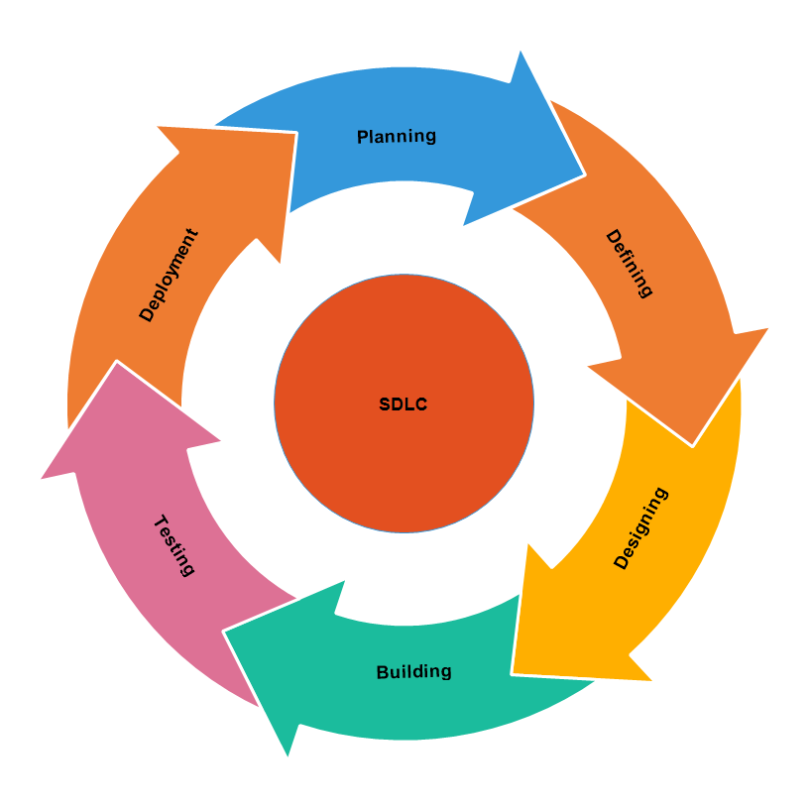

Figure 1: Software Development Life Cycle

STAGE 1: PLANNING AND REQUIREMENT ANALYSIS

Requirement analysis is the most important and fundamental stage in SDLC. It is performed by the senior members of the team with inputs from the customer, the sales department, market surveys and domain experts in the industry. This information is then used to plan the basic project approach and to conduct product feasibility study in the economical, operational and technical areas.

Planning for the quality assurance requirements and identification of the risks associated with the project is also done in the planning stage. The outcome of the technical feasibility study is to define the various technical approaches that can be followed to implement the project successfully with minimum risks.

STAGE 2: DEFINING REQUIREMENTS

Once the requirement analysis is done the next step is to clearly define and document the product requirements and get them approved from the customer or the market analysts. This is done through an SRS (Software Requirement Specification) document which consists of all the product requirements to be designed and developed during the project life cycle.

STAGE 3: DESIGNING THE PRODUCT ARCHITECTURE

SRS is the reference for product architects to come out with the best architecture for the product to be developed. Based on the requirements specified in SRS, usually more than one design approach for the product architecture is proposed and documented in a DDS - Design Document Specification.

This DDS is reviewed by all the important stakeholders and based on various parameters as risk assessment, product robustness, design modularity, budget and time constraints, the best design approach is selected for the product.

A design approach clearly defines all the architectural modules of the product along with its communication and data flow representation with the external and third party modules (if any). The internal design of all the modules of the proposed architecture should be clearly defined with the minutest of the details in DDS.

STAGE 4: BUILDING OR DEVELOPING THE PRODUCT

In this stage of SDLC the actual development starts and the product is built. The programming code is generated as per DDS during this stage. If the design is performed in a detailed and organized manner, code generation can be accomplished without much hassle.

Developers must follow the coding guidelines defined by their organization and programming tools like compilers, interpreters, debuggers, etc. are used to generate the code. Different high level programming languages such as C, C++, Pascal, Java and PHP are used for coding. The programming language is chosen with respect to the type of software being developed.

STAGE 5: TESTING THE PRODUCT

This stage is usually a subset of all the stages as in the modern SDLC models, the testing activities are mostly involved in all the stages of SDLC. However, this stage refers to the testing only stage of the product where product defects are reported, tracked, fixed and retested, until the product reaches the quality standards defined in the SRS.

STAGE 6: DEPLOYMENT IN THE MARKET AND MAINTENANCE

Once the product is tested and ready to be deployed it is released formally in the appropriate market. Sometimes product deployment happens in stages as per the business strategy of that organization. The product may first be released in a limited segment and tested in the real business environment (UAT- User acceptance testing).

Then based on the feedback, the product may be released as it is or with suggested enhancements in the targeting market segment. After the product is released in the market, its maintenance is done for the existing customer base.

(Elliot, 1970)

## Process Model

The process model used is Spiral model. The spiral model combines the idea of iterative development with the systematic, controlled aspects of the waterfall model. This Spiral model is a combination of iterative development process model and sequential linear development model i.e. the waterfall model with a very high emphasis on risk analysis. It allows incremental releases of the product or incremental refinement through each iteration around the spiral.

This model is best used for large projects which involves continuous enhancements. There are specific activities which are done in one iteration (spiral) where the output is a small prototype of the large software. The same activities are then repeated for all the spirals till the entire software is build.

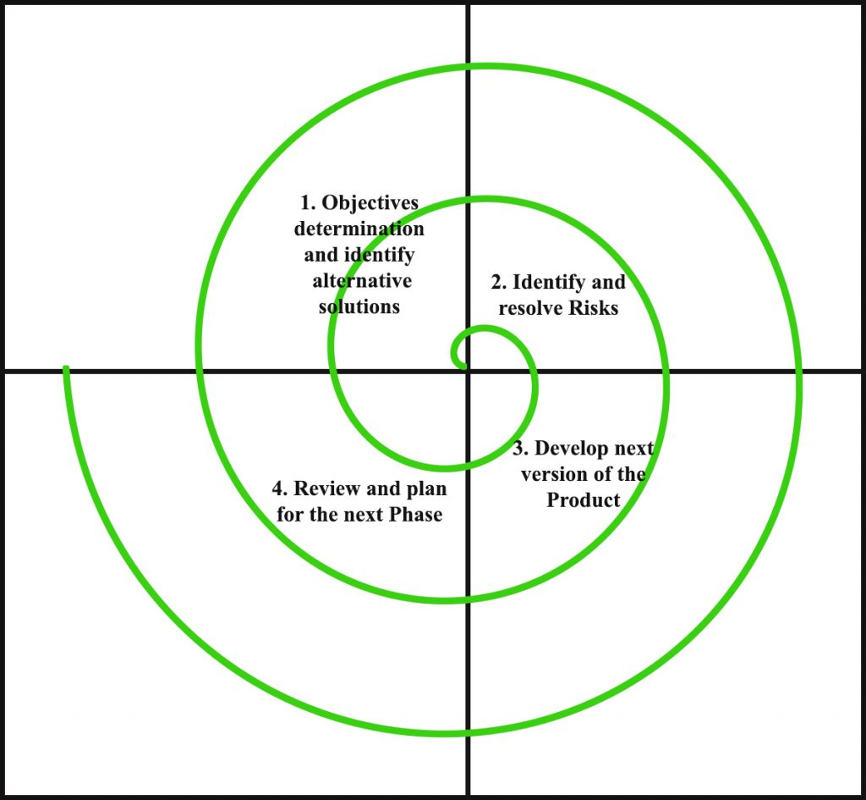

Figure 2: Spiral Model

The Spiral Model is widely used in the software industry as it is in sync with the natural development process of any product, i.e. learning with maturity which involves minimum risk for the customer as well as the development firms.

The following pointers explain the typical uses of a Spiral Model −

* When there is a budget constraint and risk evaluation is important.
* For medium to high-risk projects.
* Long-term project commitment because of potential changes to economic priorities as the requirements change with time.
* Customer is not sure of their requirements which is usually the case.
* Requirements are complex and need evaluation to get clarity.
* New product line which should be released in phases to get enough customer feedback.
* Significant changes are expected in the product during the development cycle.

The advantage of spiral lifecycle model is that it allows elements of the product to be added in, when they become available or known. This assures that there is no conflict with previous requirements and design.

This method is consistent with approaches that have multiple software builds and releases which allows making an orderly transition to a maintenance activity. Another positive aspect of this method is that the spiral model forces an early user involvement in the system development effort.

On the other side, it takes a very strict management to complete such products and there is a risk of running the spiral in an indefinite loop. So, the discipline of change and the extent of taking change requests is very important to develop and deploy the product successfully.

(Strashan, 2004)

# SYSTEM ANALYSES

## Study of Current System

Currently there are many online shopping sites for shopping different product. The most commonly use online shopping application is Amazon.com, Flipkart.com, etc. This application is having different features like add to cart, add to wish list, Category wise shopping, budget wise shopping, brand wise shopping and many such features.

## Problem and Weaknesses of Current System

Current system doesn’t have much problem and weakness but weaknesses that I can observe or I can say is that they don’t have rent option on clothes and cheaper price with good quality.

## Requirements of New System

Through our new application, customer can rent items with lower prices and good quality. The main objective of this application is to provide the goods and product all over the city with just one click of a button. In this system user can rent a product by category, rent product by budget, add the product into the cart and later order that product, etc.

## Feasibility Study

When the client approaches the organization for getting the desired product developed, it comes up with rough idea about what all functions the software must perform and which all features are expected from the software.

Referencing to this information, the analysts does a detailed study about whether the desired system and its functionality are feasible to develop.

This feasibility study is focused towards goal of the organization. This study analyzes whether the software product can be practically materialized in terms of implementation, contribution of project to organization, cost constraints and as per values and objectives of the organization. It explores technical aspects of the project and product such as usability, maintainability, productivity and integration ability.

The output of this phase should be a feasibility study report that should contain adequate comments and recommendations for management about whether or not the project should be undertaken.

Feasibility test is conducted by Enlighten InfoSystems and the requirements also provided by company.

(Roy, 2004)

## Requirements Validation

* Password should be of 6 characters or more
* Email Id should be in proper format with “.” And “@” symbols
* Contact number should be of 10 digits
* Contact number should contain numeric values
* Pin-code number should be of 6 numbers
* Customer cannot select previous dates for pick-up date
* Admin cannot select alphabetic values in quantity

## Functions of System

### Use Case Diagram

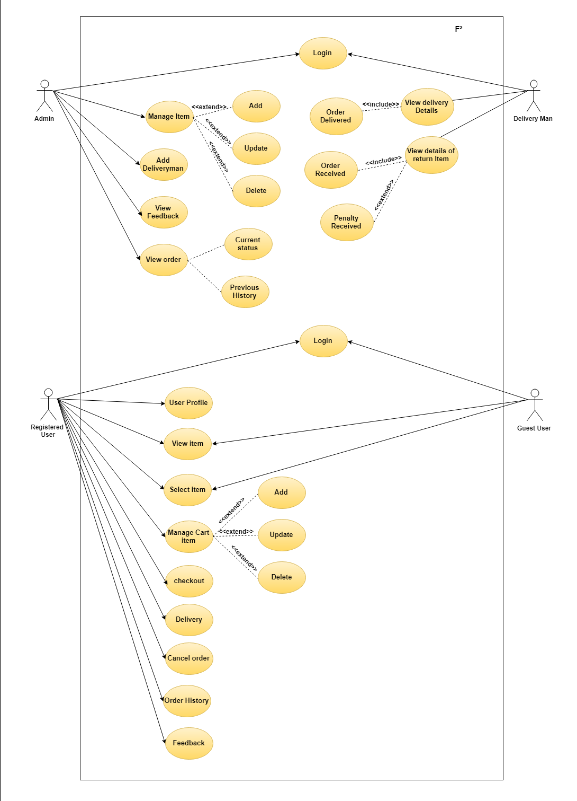

Figure 3: Use Case Diagram

## Data Modeling

### E-R diagram

Figure 1: ER Diagram

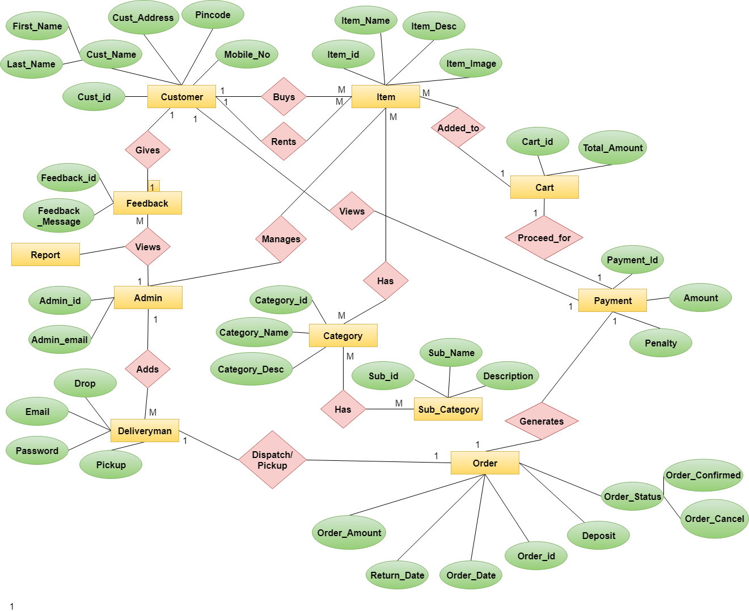

### Class diagram

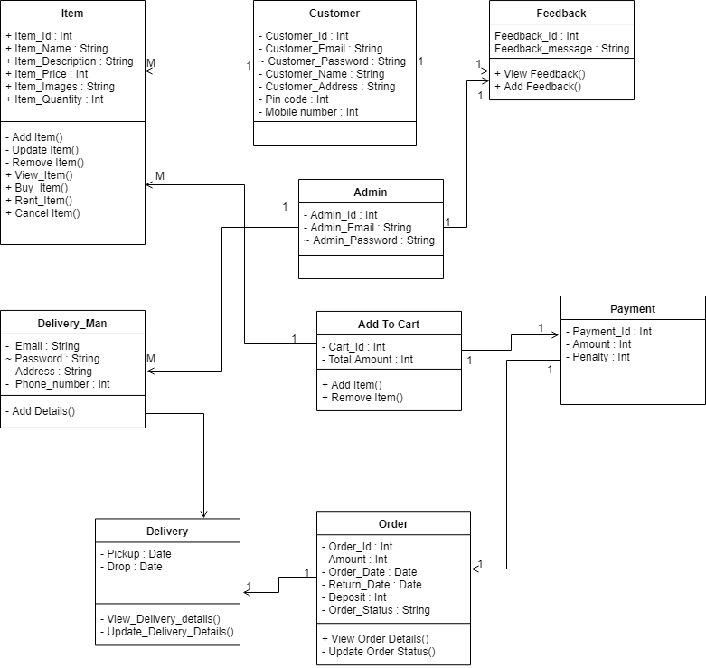

Figure 5: Class Diagram

### Database diagram

# C:\Users\Dharmesh Patel\Desktop\database.png

Figure 6: Database

### 

Figure 7: Admin_Order (Database)

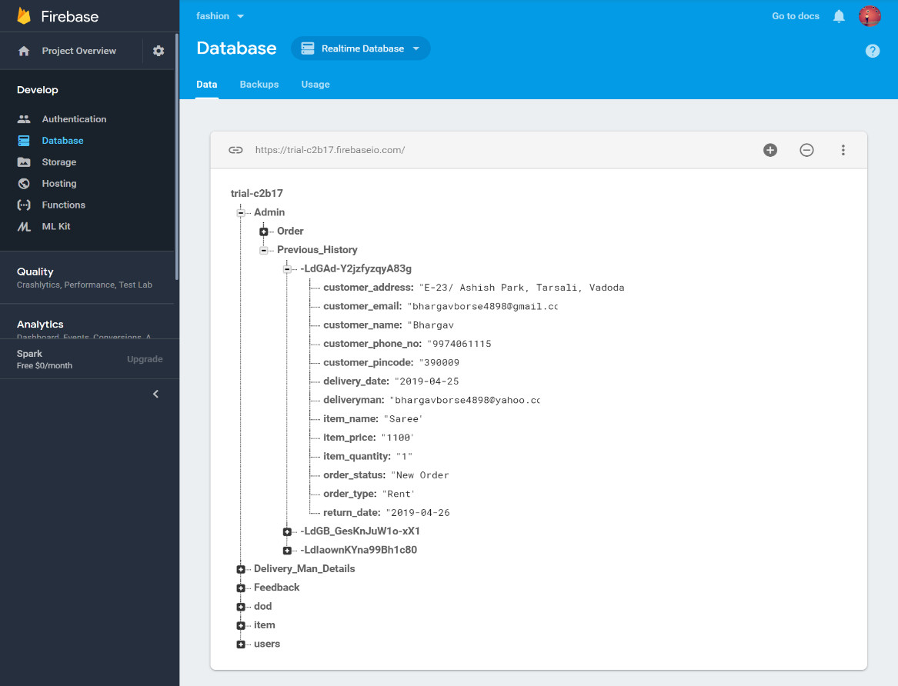

Figure 8: Admin_Previous_History (Database)

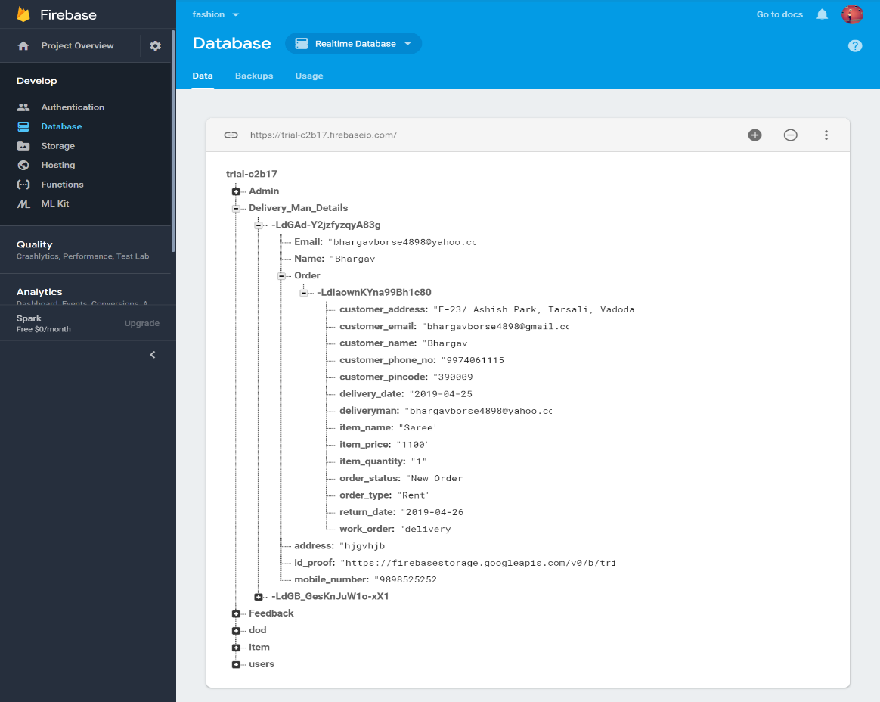

Figure 9 : Deliveryman Details (Database)

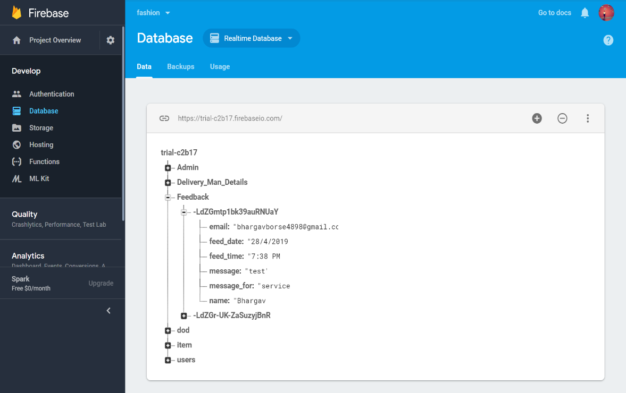

Figure 10: Feedback (Database)

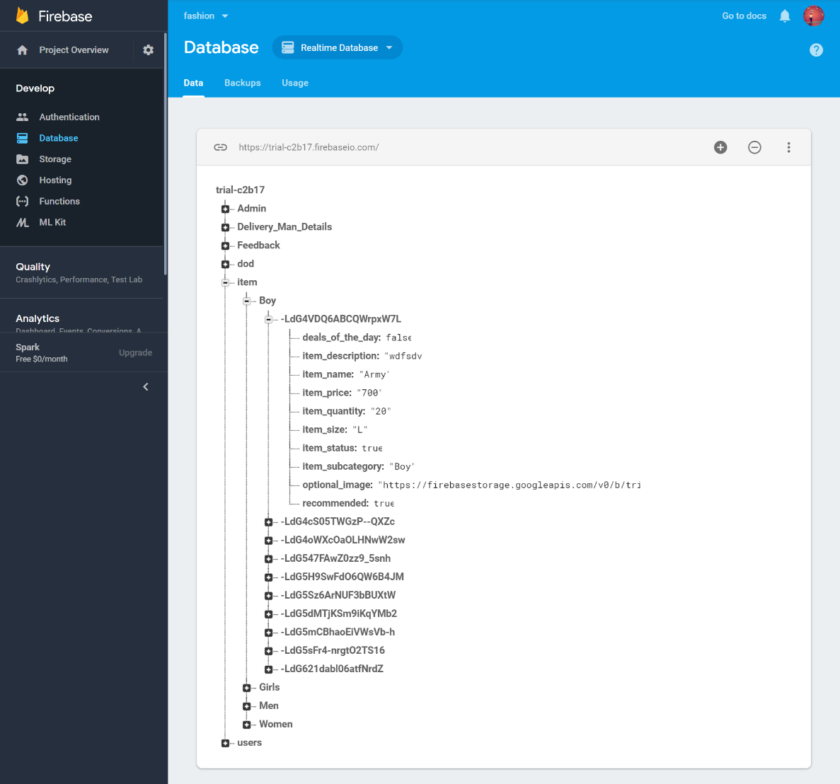

Figure 11: Boy’s_Item (Database)

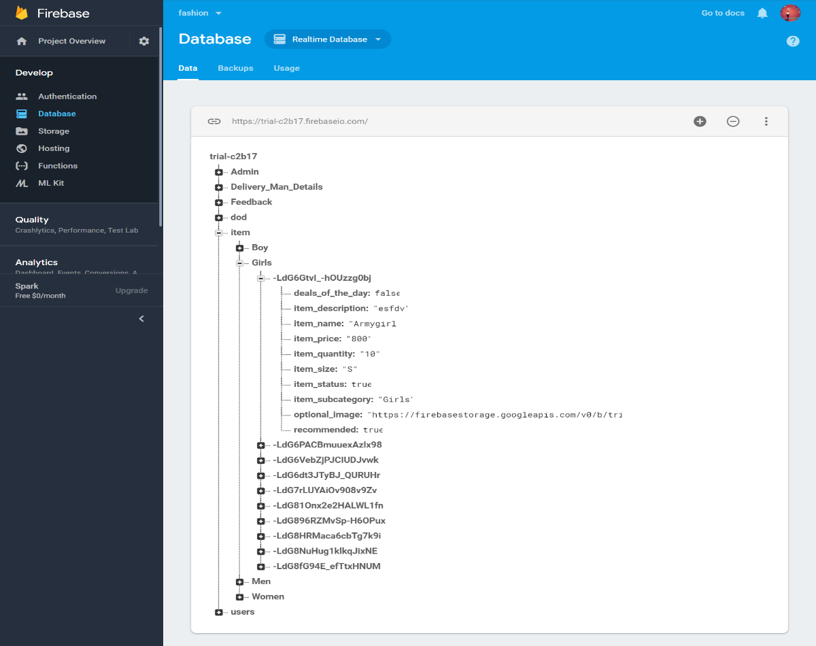

Figure 12: Girl’s_Item (Database)

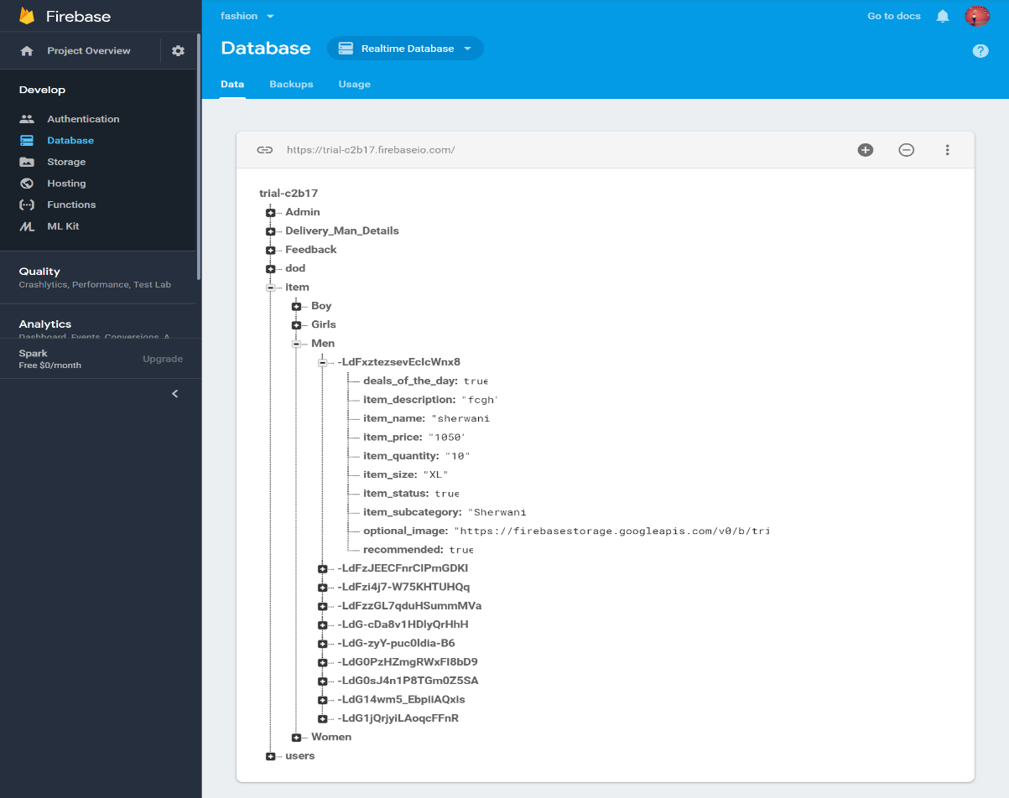

Figure 13: Men’s_Item (Database)

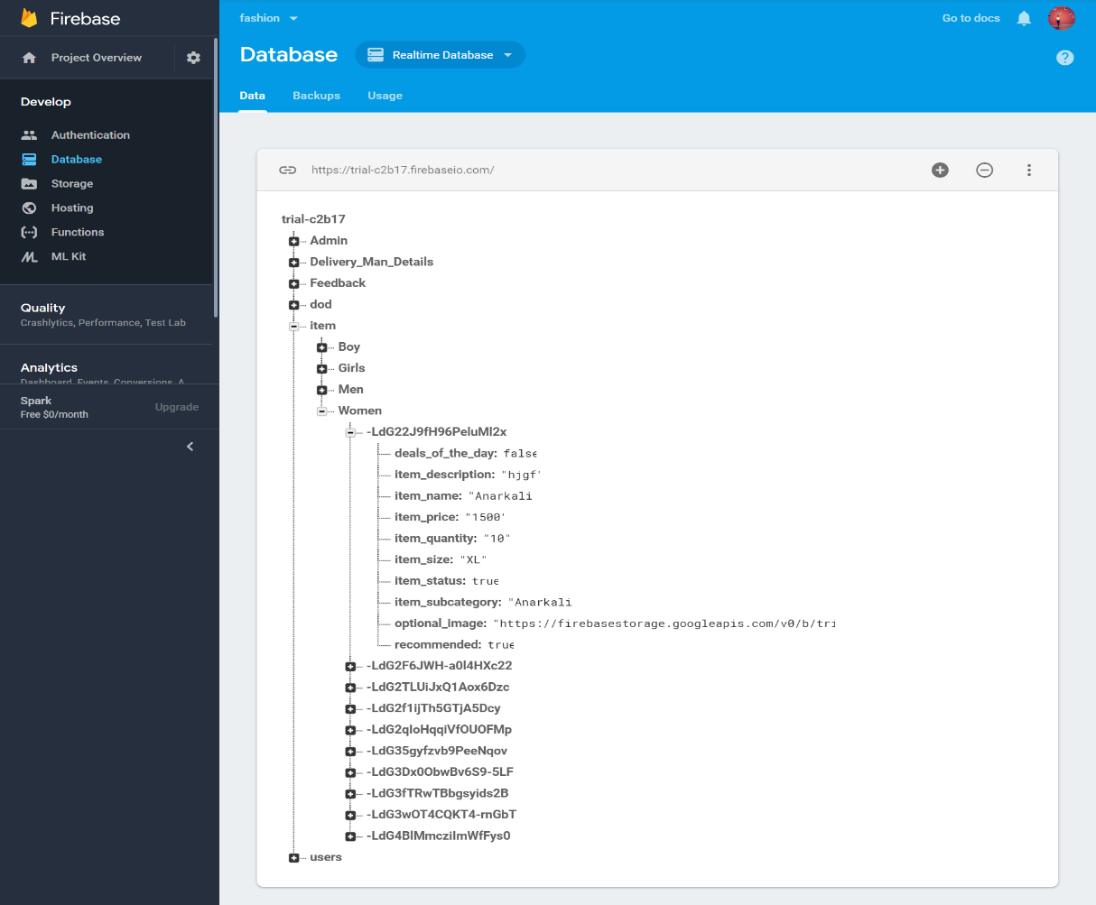

Figure 14: Women’s_Item (Database)

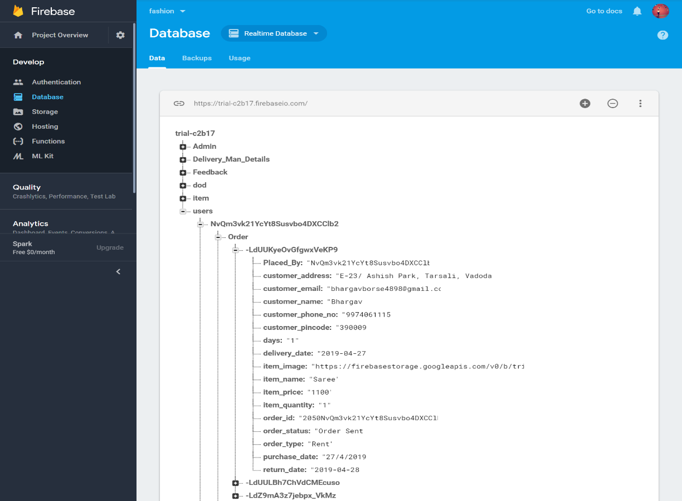

Figure 15: User(1) (Database)

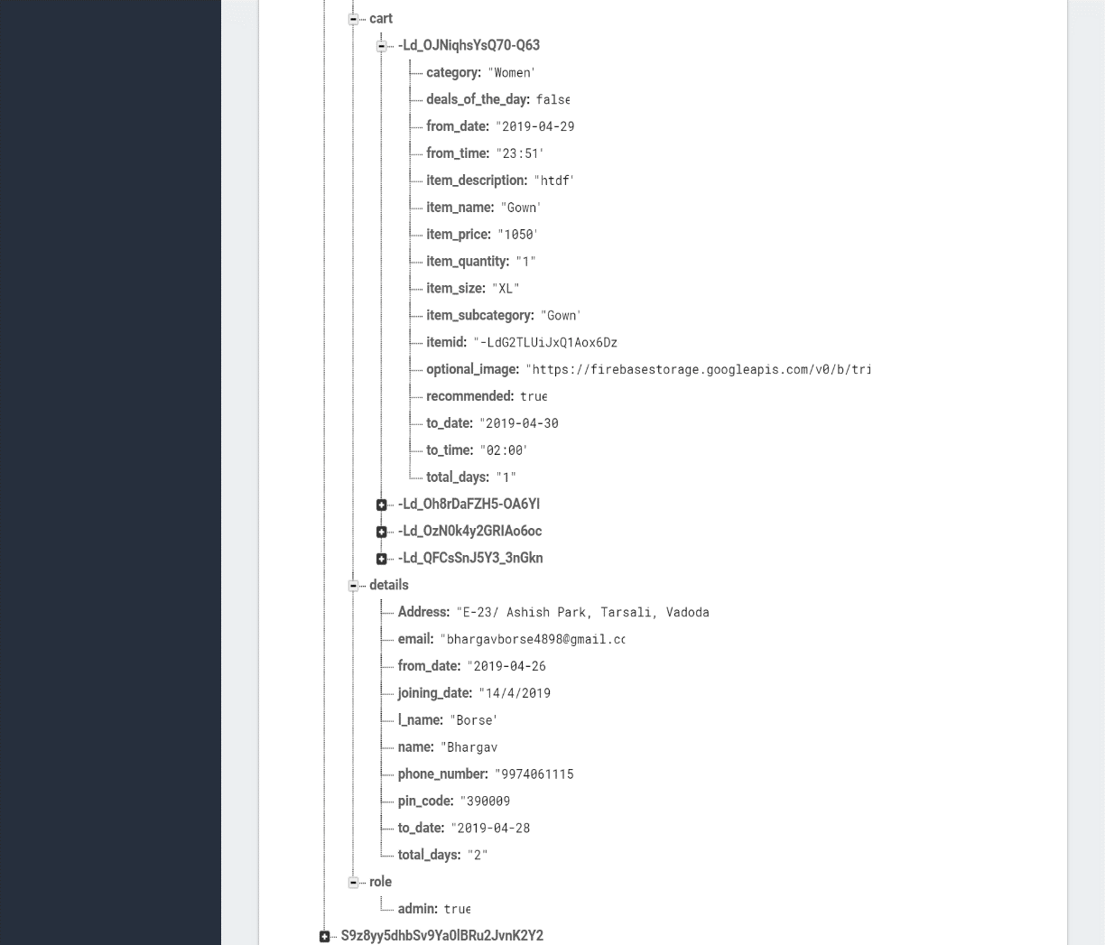

Figure 16: User(2)(Database)

## Functional and Behavioral Modeling

### Activity Diagram

**User Login**

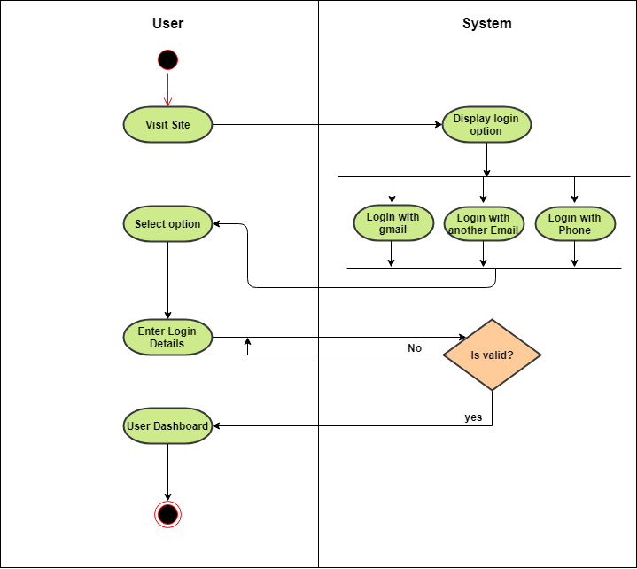

Figure 17: User Login Activity Diagram

**Dress Selection Option(User)**

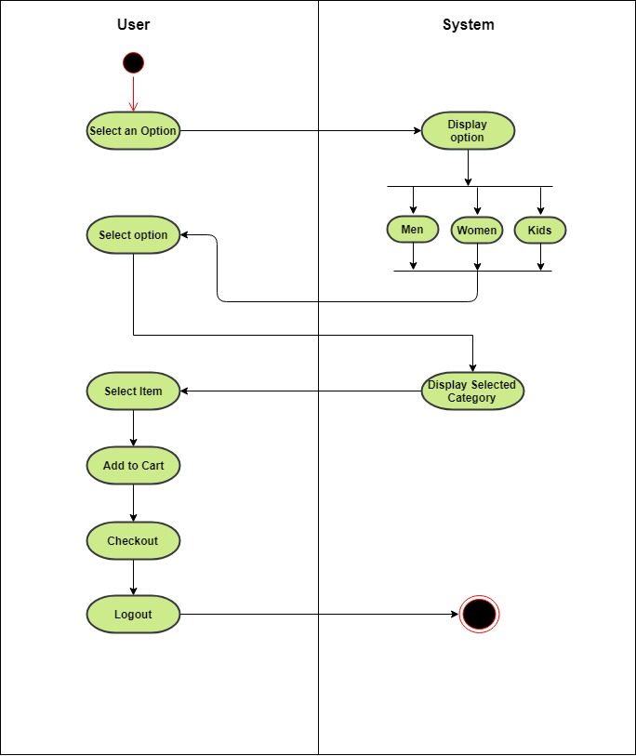

Figure 18: Dress Selection Option Activity Diagram

**Add To Cart(User)**

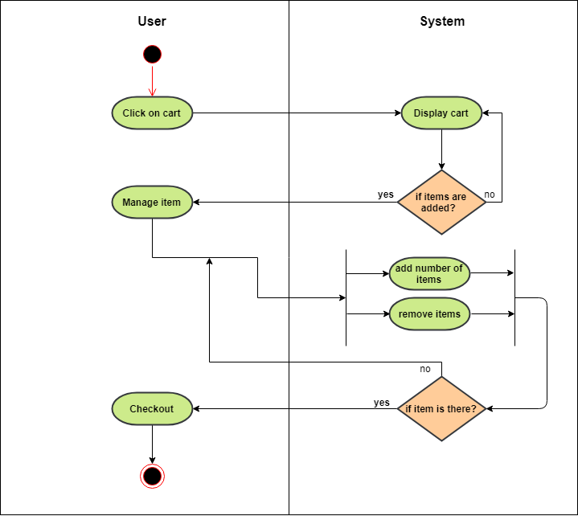

Figure 19: Add To Cart Activity diagram

**Checkout(User)**

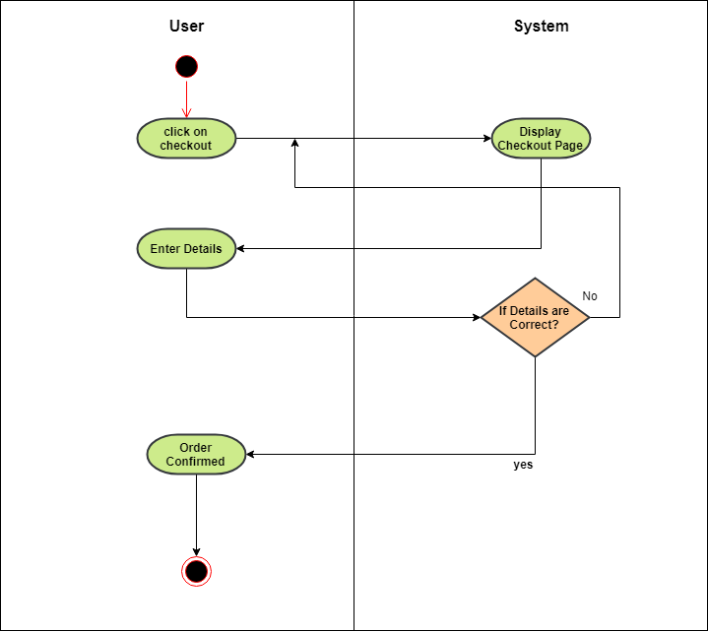

Figure 20: Checkout Activity Diagram

**Admin Login**

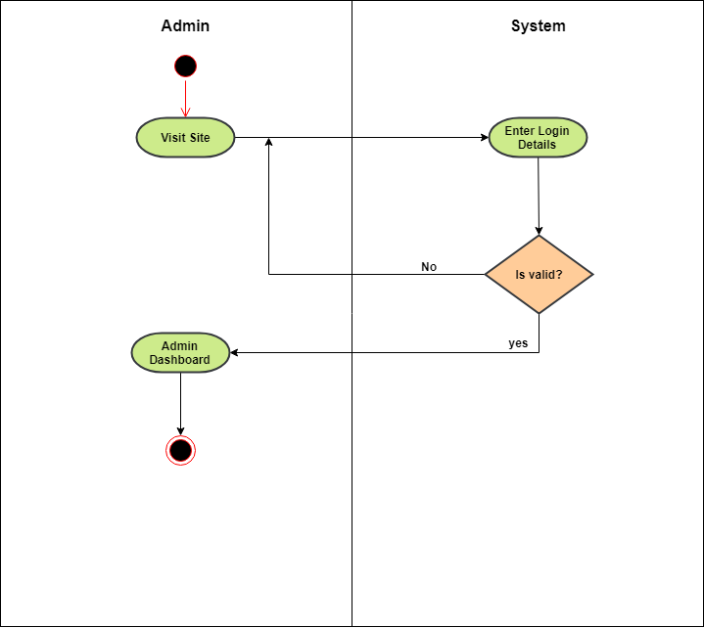

Figure 21: Admin Login Activity Diagram

**Manage Item(Admin)**

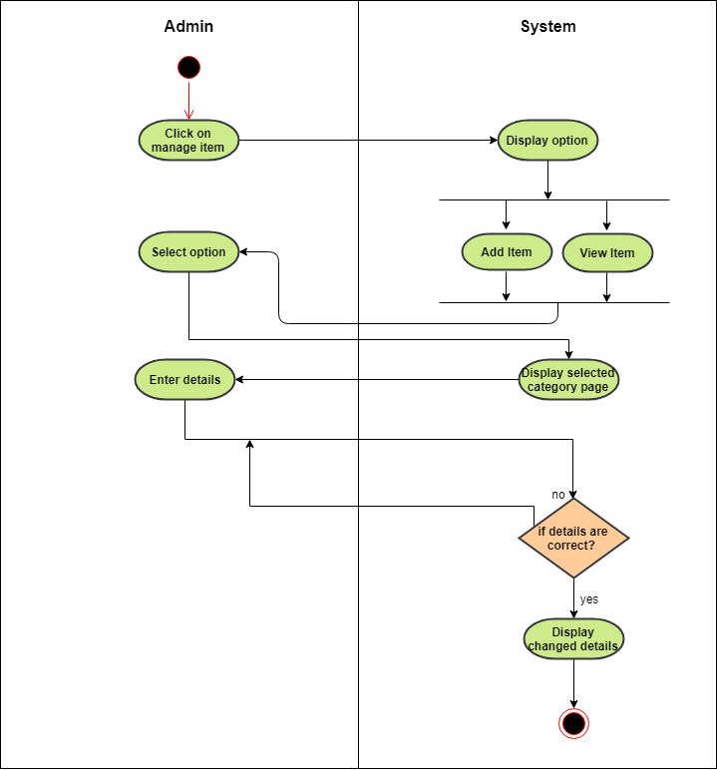

Figure 22: Manage Item Activity Diagram

**Rental Details(Admin)**

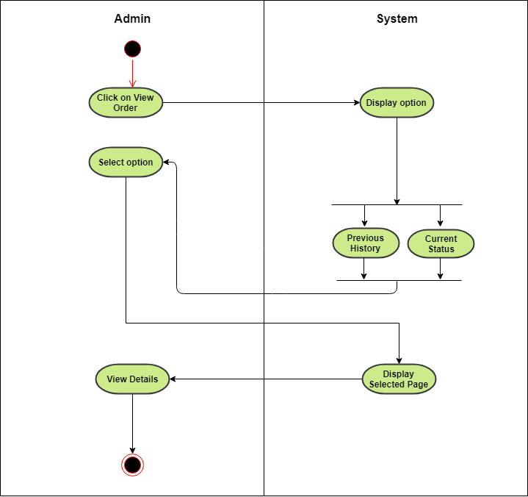

Figure 23: Rental Details Activity Diagram

**Penalty(Admin)**

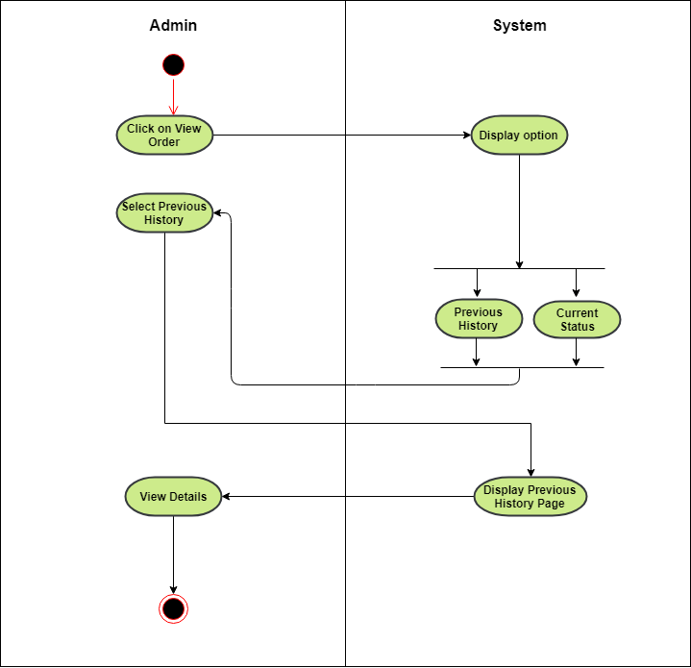

Figure 24: Penalty Details Activity Diagram

**Deliveryman Login:-**

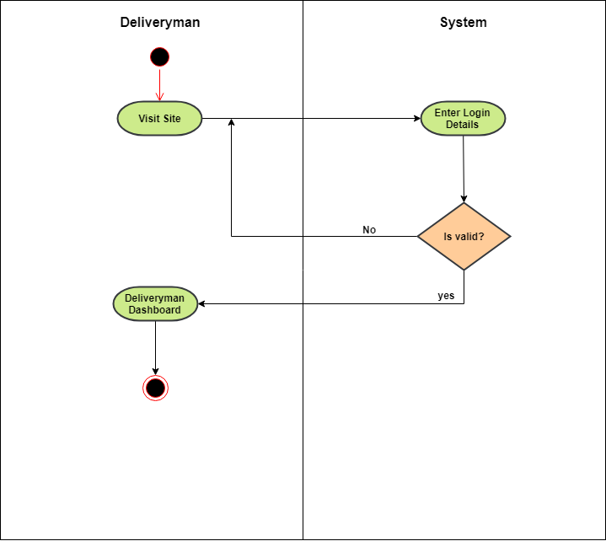

Figure 25: Deliveryman Login Activity Diagram

**Delivery Details (Deliveryman) :-**

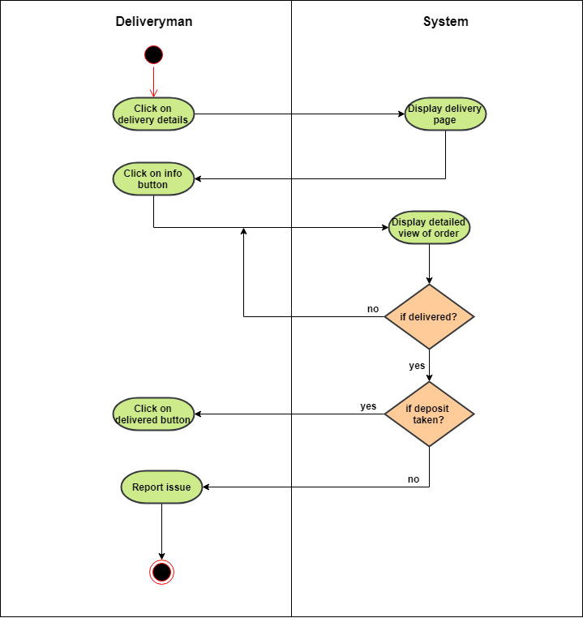

Figure 26: Delivery Details Activity Diagram

**Return Item (Deliveryman) :-**

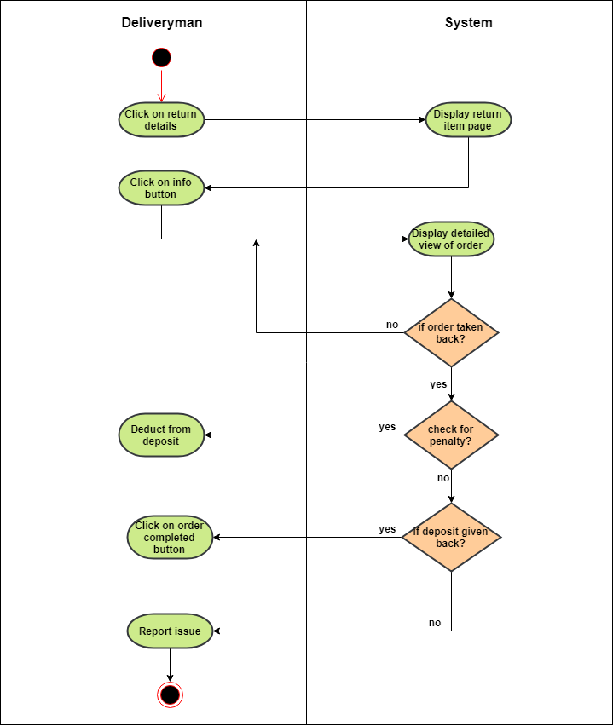

Figure 27: Return Item Activity Diagram

### Sequence Diagram

**Order Item:**

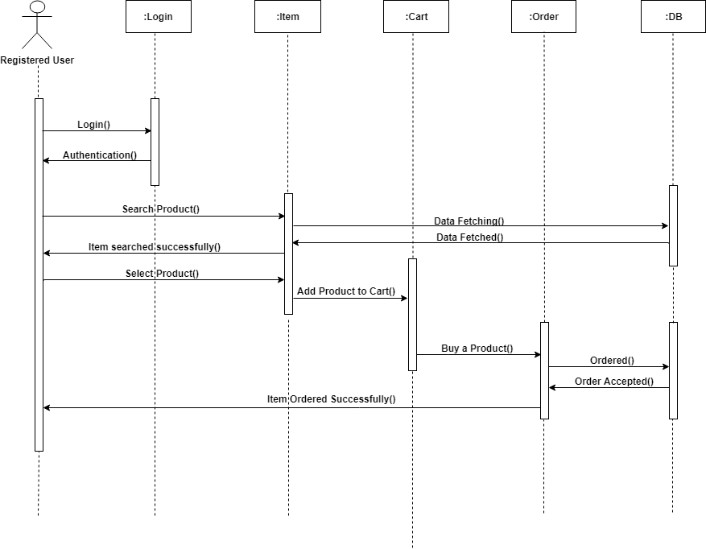

Figure 28: Order Item Sequence diagram

**Rent Item:**

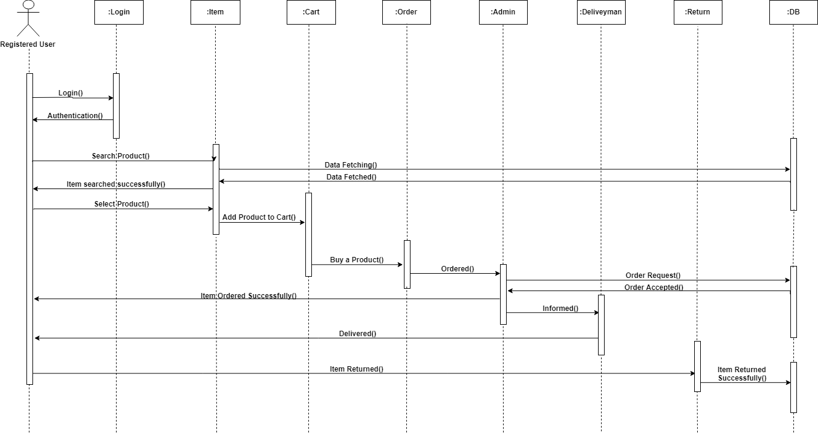

Figure 29: Rent Item Sequence diagram

**Adding Deliveryman(Admin)**

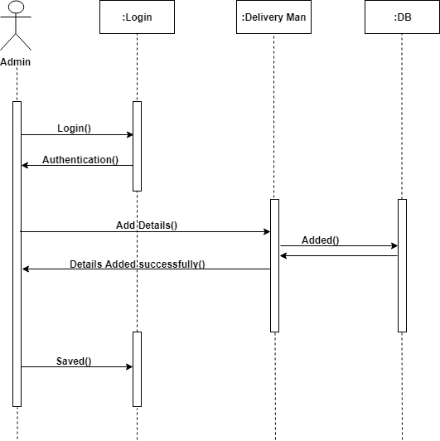

Figure 30: Adding Deliveryman Sequence diagram

**Manage Item(Admin)**

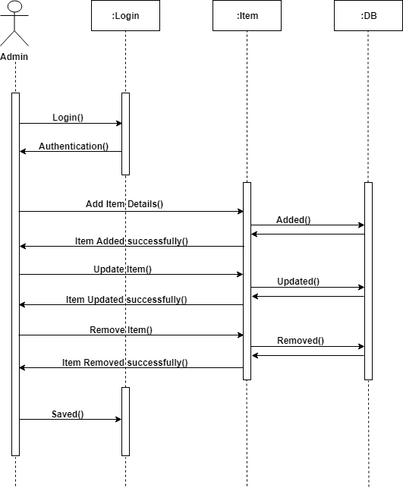

Figure 31: Manage Item Sequence diagram

## Control flow diagram

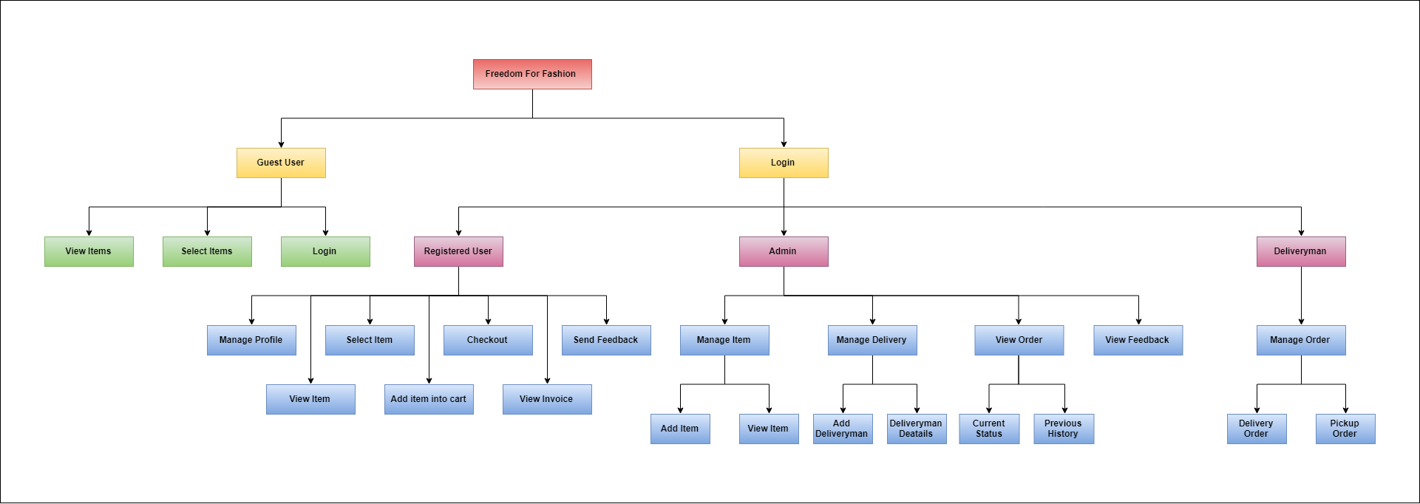

Figure 32 : Control Flow Diagram

# SYSTEM DESIGN

## Tables and Relationship

|  |  |  |  |  |
| --- | --- | --- | --- | --- |
| **Admin** | | | | |
| **Field Name** | **Data Type** | **Size** | **Constraint** | **Description** |
| Admin_Email | Varchar | 50 | Not Null | Admin_Email is used for Login into admin dashboard. |
| Password | Varchar | 20 | Not Null | Password is necessary for login via email. |

Table 2: Admin Table

|  |  |  |  |  |
| --- | --- | --- | --- | --- |
| **Customer** | | | | |
| **Field Name** | **Data Type** | **Size** | **Constraint** | **Description** |
| Customer_Id | Int | 5 | Primary Key (Auto Increment) | Customer_Id is unique key for every Customer. |
| Customer_Name | Varchar | 30 | Not Null | Customer_Name is required for Customer identification. |
| Email_Id | Varchar | 50 | Not Null | Email_id is required for buy or rent a item. |
| Password | Varchar | 20 | Not Null | Password is necessary for login via email. |
| Address | Varchar | 100 | Not Null | Address is required for delivery purpose |
| Pincode | Int | 6 | Not Null | Pincode is used for find a delivery location area |
| Mobile number | Big Int | 10 | Not Null | Mobile number is used for contact. |

Table 3: Customer table

|  |  |  |  |  |
| --- | --- | --- | --- | --- |
| **Item** | | | | |
| **Field Name** | **Data Type** | **Size** | **Constraint** | **Description** |
| Item_Id | Int | 5 | Primary Key (Auto Increment) | Item_Id is unique key for every item. |
| Item_Name | Varchar | 30 | Not Null | Item_Name is a name of particular Item. |
| Item_Description | Varchar | 200 | Not Null | Item_Description is Description of any item. |
| Item_Price | Int | 6 | Not Null | Item_Price is the Price of particular price of item. |
| Item_Image | Varchar | 200 | Not Null | Item Image is image of any particular item. |
| Item_Quantity | Int | 5 | Not Null | Item Quantity is Quantity of any particular item. |
| Category | Varchar | 10 | Not Null | There will be four category like Men/Women/Boy/Girls |
| Subcategory | Varchar | 10 | Not Null | Subcategory is category of selected Category. |
| Deals Of The Day | Varchar | 10 | Not Null | Deals Of the Day is a function that shows some deals of that particular day. |
| Recommended | Varchar | 10 | Not Null | Recommended is a function that shows some products that is recommended by admin. |

Table 4: Item table

|  |  |  |  |  |
| --- | --- | --- | --- | --- |
| **Cart** | | | | |
| **Field Name** | **Data Type** | **Size** | **Constraint** | **Description** |
| Cart_Id | Int | 5 | Primary Key(Auto Increment) | Cart_Id is a unique key for every new cart. |
| Item_Id | Int | 5 | Foreign Key | Item_Id is Key of item added into thr cart. |
| Amount | Int | 6 | Not Null | Amount is particular amount of Cart. |

Table 5: Cart table

|  |  |  |  |  |
| --- | --- | --- | --- | --- |
| **Payment** | | | | |
| **Field Name** | **Data Type** | **Size** | **Constraint** | **Description** |
| Payment_Id | Int | 5 | Primary Key(Auto Increment) | Payment_Id is a unique key for every new Payment. |
| Amount | Int | 6 | Foreign Key | Amount is a payable amount of particular Order. |
| Penalty | Int | 6 | Not Null | Penalty is a amount that are extra charge of customer if he make any fault. |

Table 6: Payment table

|  |  |  |  |  |
| --- | --- | --- | --- | --- |
| **Order** | | | | |
| **Field Name** | **Data Type** | **Size** | **Constraint** | **Description** |
| Order_Id | Int | 5 | Primary Key (Auto Increment) | Order_Id is unique key for every new Order. |
| Item_Id | Int | 5 | Foreign Key | Item_Id is unique key for every item. |
| Order_Amount | Int | 6 | Not Null | Order_Amount is a payable amount of particular Order. |
| Order_Date | Date | - | Not Null | Order_Date is Date of item Customer buy or rent. |
| Return_Date | Date | - | Not Null | Return_Date is date when Customer Return Item. |
| Deposit | Int | 6 | Not Null | Deposit is a amount that customer has to pay when Item delivered at their place. |
| Order_Status | Varchar | 12 | Not Null | Order_status Shows that order is in which phase. |

Table 7: Order table

|  |  |  |  |  |
| --- | --- | --- | --- | --- |
| **Delivery(rent)** | | | | |
| **Field Name** | **Data Type** | **Size** | **Constraint** | **Description** |
| Email | Varchar | 50 | Primary Key(Auto Increment) | Email is a unique key For every delivery man. |
| Password | Varchar | 10 | Not Null | Password is necessary for login . |
| Order_Id | Int | 5 | Foreign key | Order_Id is unique key for every new Order. |
| DM_Id | Int | 5 | Foreign Key | DM_Id is a Foreign key for delivery man. |
| Drop | Date | 10 | Not Null | Drop is a date when delivery man has to deliver Item. |

Table 8: Delivery(Rent)Acceptancy

|  |  |  |  |  |
| --- | --- | --- | --- | --- |
| Delivery(Buy) | | | | |
| Field Name | Data Type | Size | Constraint | Description |
| Email | Varchar | 50 | Primary Key(Auto Increment) | Email is a unique key For every delivery man. |
| Password | Varchar | 10 | Not Null | Password is necessary for login . |
| Order_Id | Int | 5 | Foreign key | Order_Id is unique key for every new Order. |
| DM_Id | Int | 5 | Foreign Key | DM_Id is a Foreign key for delivery man. |
| Pickup | Date | 10 | Not Null | Pickup is a date when delivery man has to pick Item. |

Table 9: Delivery(Buy) acceptancy

|  |  |  |  |  |
| --- | --- | --- | --- | --- |
| **Feedback** | | | | |
| **Field Name** | **Data Type** | **Size** | **Constraint** | **Description** |
| Feedback_Id | Int | 5 | Primary Key(Auto Increment) | Feedback_Id is a unique key for every new Feedback. |
| Customer_Name | Varchar | 30 | Not Null | Customer_Name is required for Customer identification. |
| Email_id | Varchar | 50 | Not Null | Email_id is required for Customer identification. |
| Feedback_Message | Varchar | 200 | Not Null | Feedback_Messege is a feedback message Given by Customer. |

Table 10: Feedback table

|  |  |  |  |  |
| --- | --- | --- | --- | --- |
| **Delivery Man** | | | | |
| **Field Name** | **Data Type** | **Size** | **Constraint** | **Description** |
| DM_Id | Int | 5 | Primary Key(Auto Increment) | DM_Id is a unique id for every new delivery man. |
| DM_Name | Varchar | 30 | Not Null | DM_Name is name of particular name of delivery man. |
| Address | Varchar | 100 | Not Null | Address is required for some id proof. |
| Mobile Number | Big Int | 10 | Not Null | Mobile number is used for contact. |
| Deliveryman Image | Varchar | 200 | Not Null | Deliveryman image for identification of deliveryman. |
| Id_Proof | Varchar | 200 | Not Null | Id_proof is for security purpose. |

Table 11: Deliveryman table

## System Procedural Design

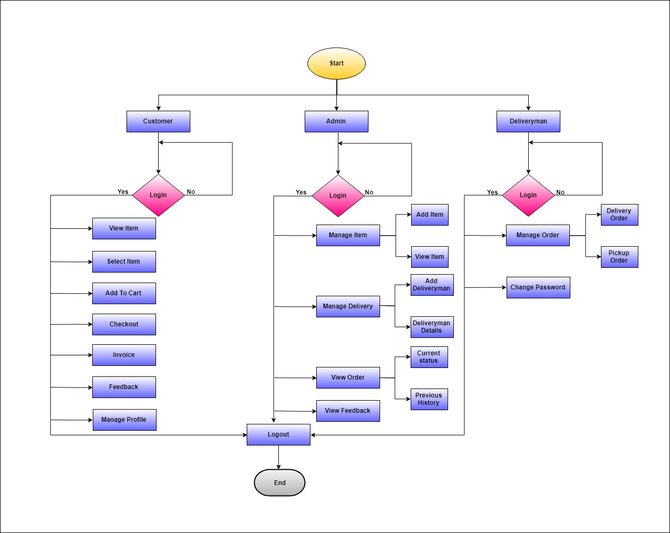

Figure 33: Flowchart

## Design Pseudo Code

1. Select user
   1. Customer
   2. Admin
   3. Deliveryman
2. If user customer
   1. Login into the system
   2. If email id and password wrong, display error
   3. else email and password right
   4. If forgot password
      1. Display forgot password popup
      2. Enter email id
      3. Link will be sent to that entered email
   5. Wrong email
   6. If else welcome details page(if user is already login once)
   7. Else Display welcome page(First time user)
   8. Select category
      1. If select Men’s/Women/kids Clothing(it shows respective pages)
3. Display men/women/kids cloths(it shows respective pages)
4. View Items
5. Add to cart
6. Checkout
7. Generate invoice
   * 1. If else select Deals of the day
8. Display list of deals
9. View item
10. Add to cart
11. Checkout
12. Generate invoice
    * 1. If else select Recommended
13. Display list of items
14. View Item
15. Add to cart
16. Checkout
17. Generate Invoice
    * 1. If else select send feedback
18. Display feedback form
19. Feedback send, display successfully send feedback
    * 1. if else select profile
20. update profile details
21. Display successfully updated profile
    1. else logout
22. if else user admin
    1. login into the system
    2. If email id and password wrong, display error
    3. else email and password right
    4. Display welcome page
    5. Select Module
       1. if select mange item
23. if select add item
24. display add item form
25. fill details and add item
26. else select view item(men/women/boy/girl)
27. display items(categorized)
28. can update or inactive item
    * 1. if else select manage delivery
29. if select add deliveryman
30. display add deliveryman form
31. fill details and add deliveryman
32. else select view deliveryman details
33. can view details of deliveryman
    * 1. if else select view order
34. if select current status
35. display current orders
36. select particular order
37. display order details form
38. can select deliveryman
39. else select previous history
40. display previous orders
41. select particular order
42. can view order details
    * 1. else select view feedback
43. Display feedback list
    1. else logout
44. else deliveryman
    1. login into the system
    2. If email id and password wrong, display error
    3. else email and password right
    4. Display welcome page
    5. Select Order Details Module
       1. if select delivery order
45. display orders
46. select particular order
47. display order details form
48. can update delivery status
    * 1. if select pickup order
49. display orders
50. select particular order
51. display order details form
52. can update delivery status
    1. If Select Change Password
       1. Enter registered email
       2. Can change password from link which is sent to their email.
    2. else logout

## Input/ Output and Interface Design (wireframes)

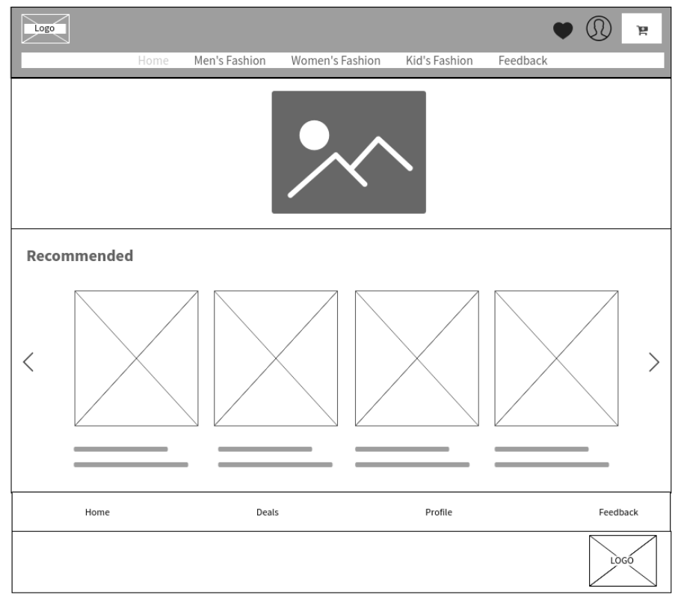

Figure 34: Main Page(User)

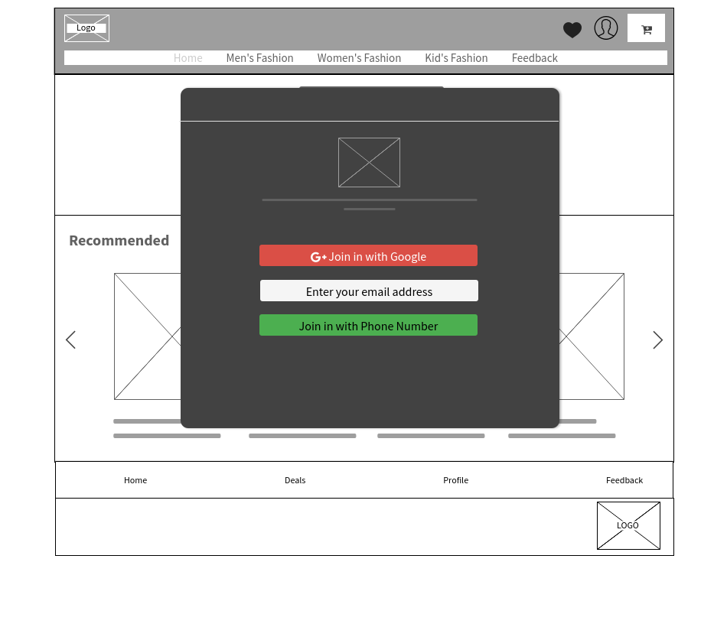

Figure 35: User Login

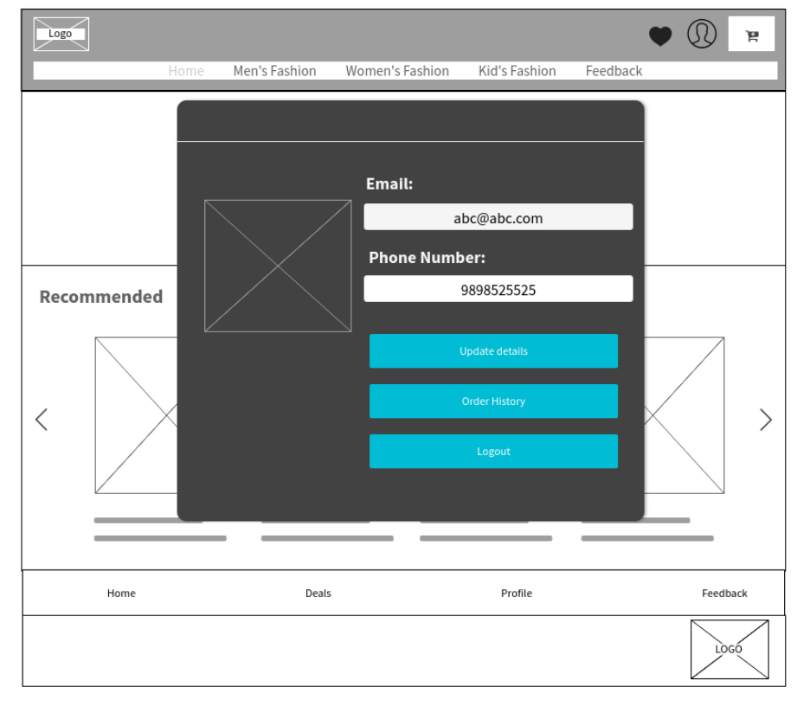

Figure 36 : Profile page(User)

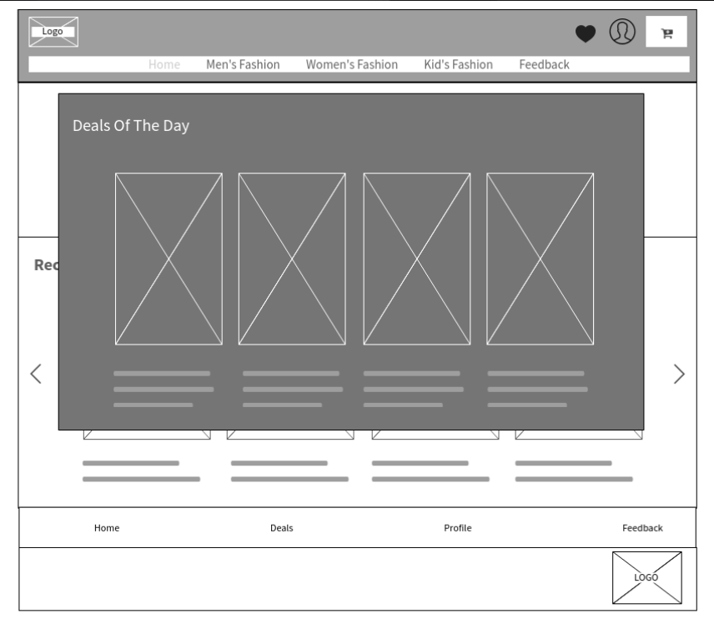

Figure 37: Deals Of The Day(User)

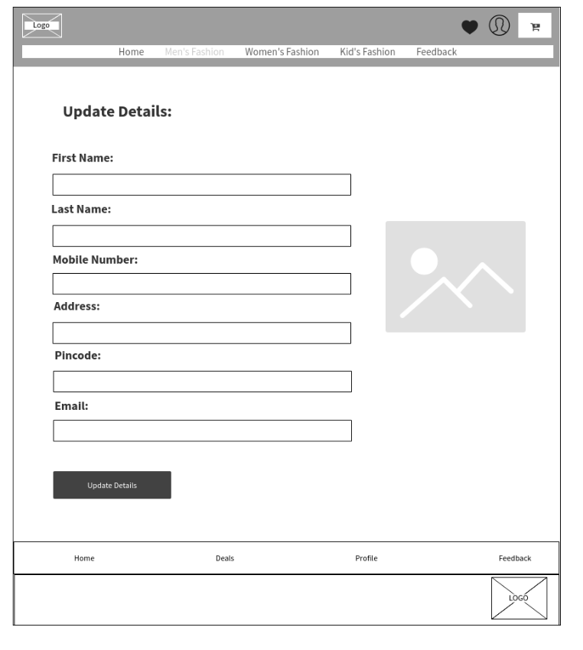

Figure 38: Update Details Page(User)

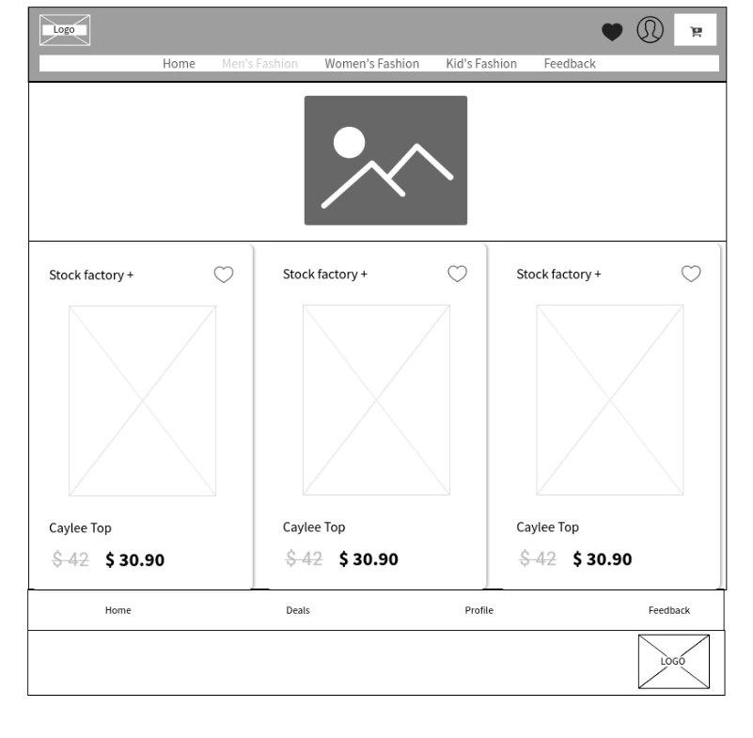

Figure 39: Men/Women/Kids Category Page(User)

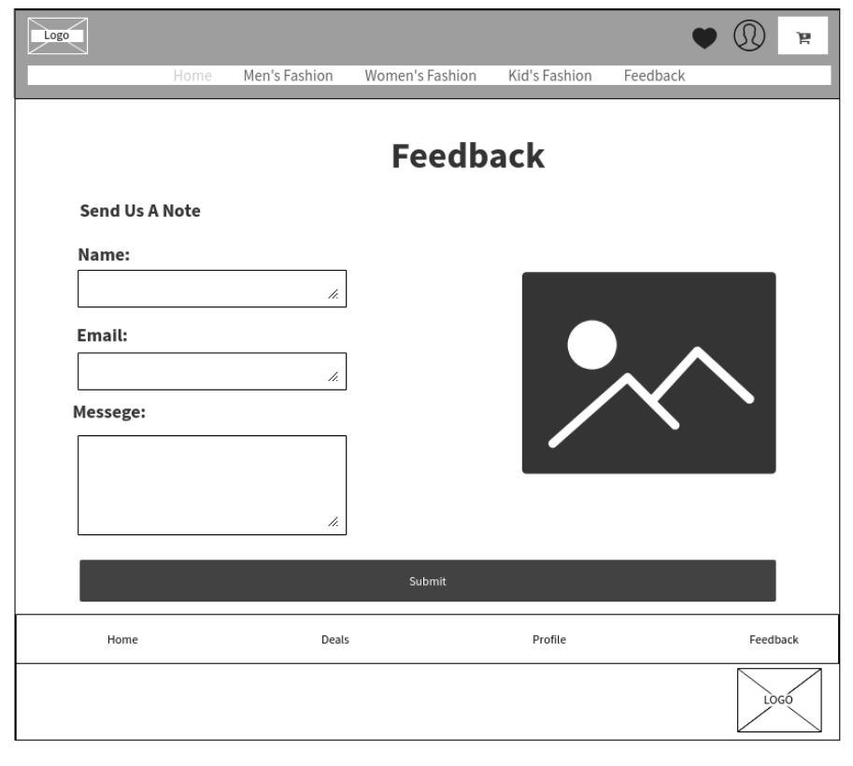

Figure 40: Feedback(User)

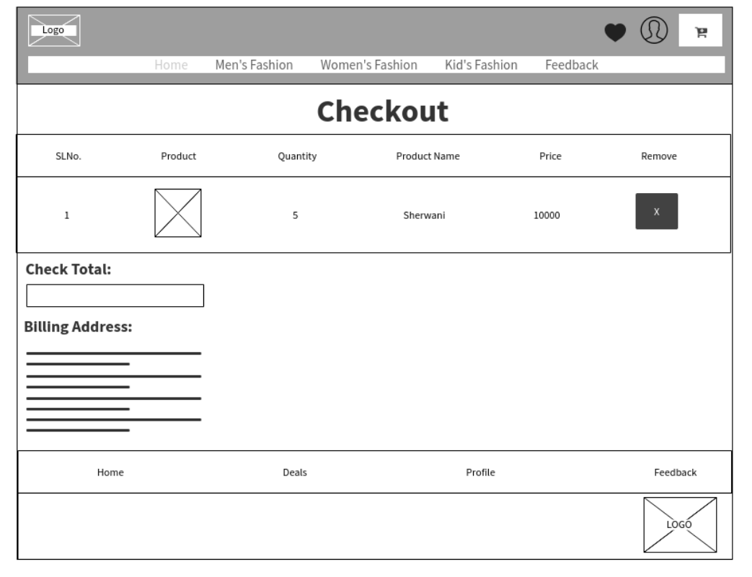

Figure 41: Checkout

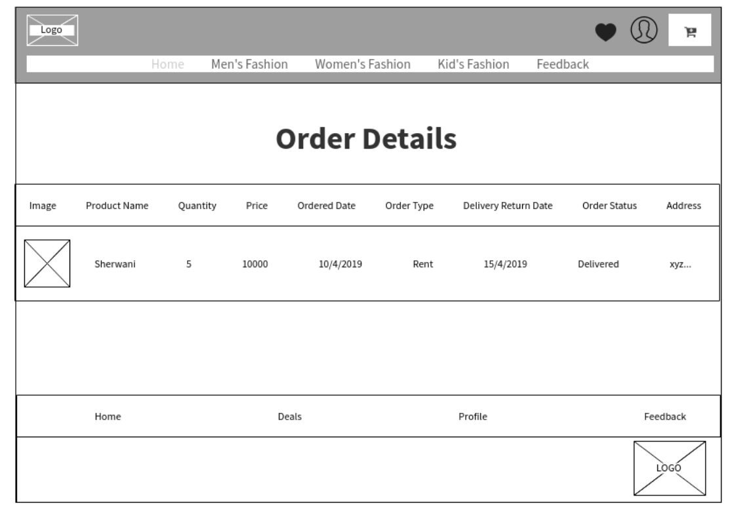

Figure 42: Order History(User)

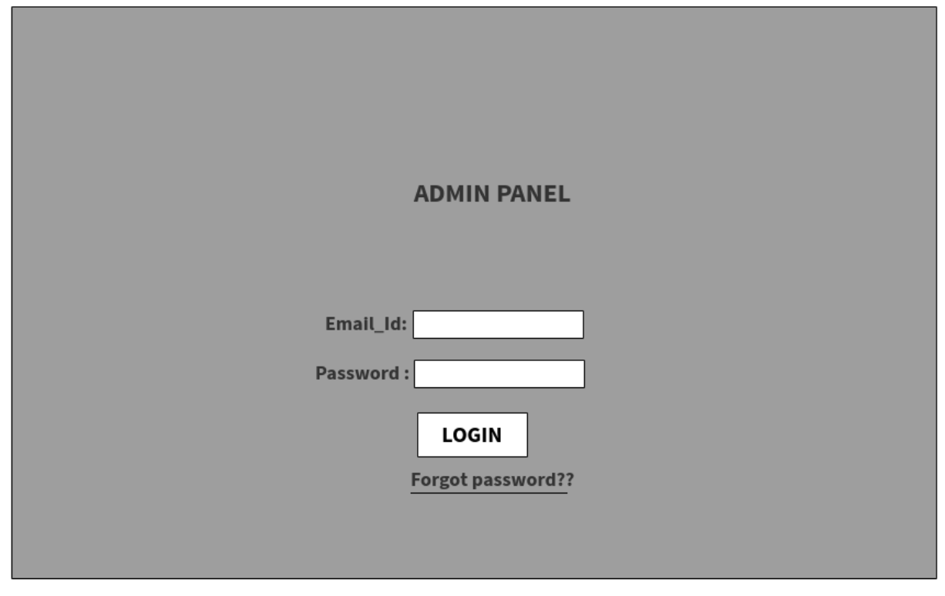

Figure 43: Admin Login

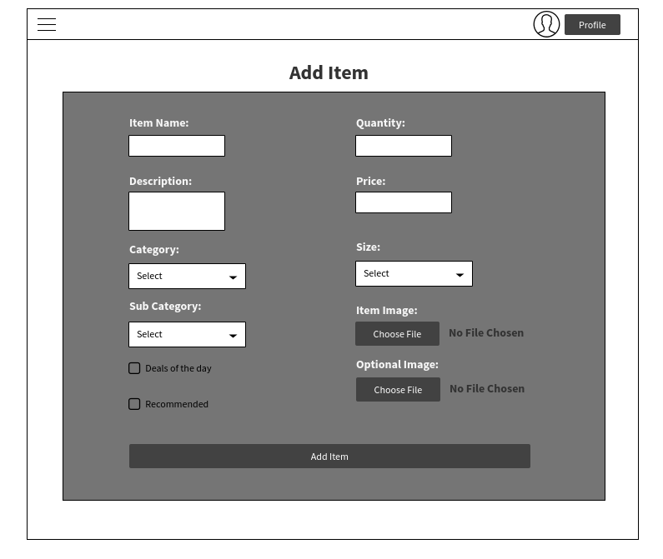

Figure 44: Add Item

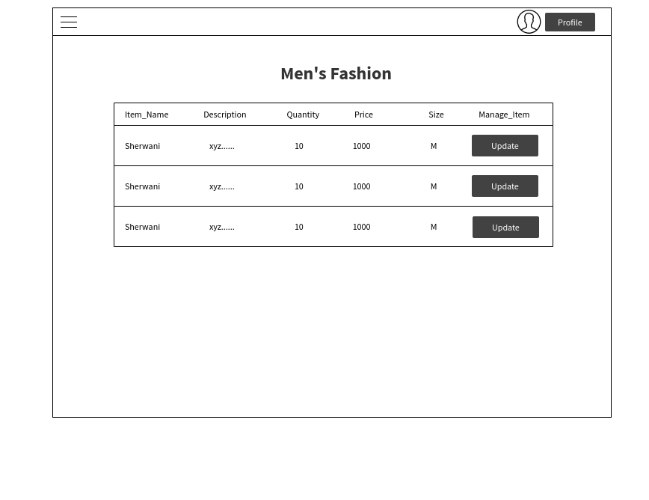

Figure 45: View Item Men(Admin)

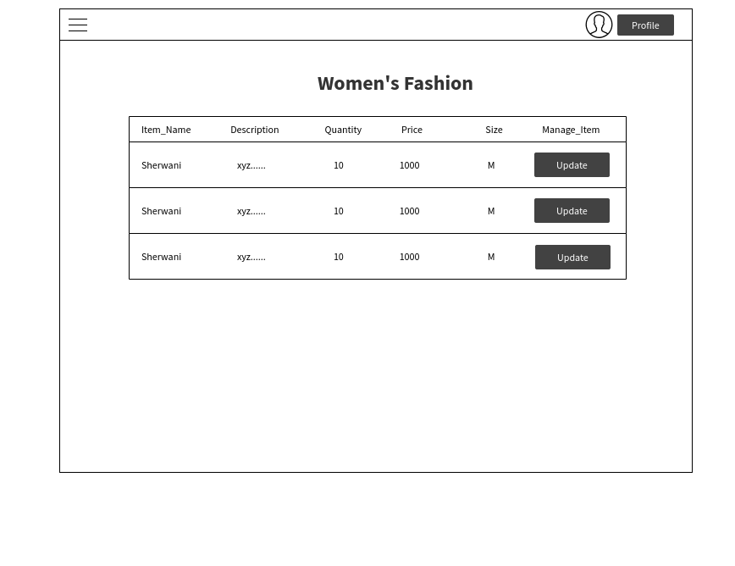

Figure 46: View Item Women(Admin)

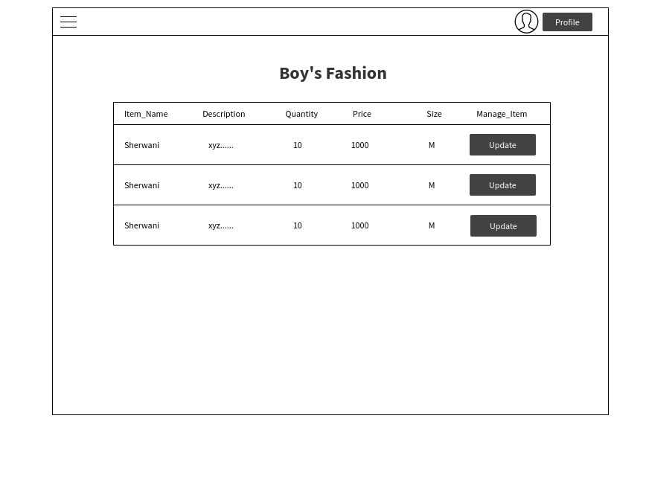

Figure 47: View Item Boy(Admin)

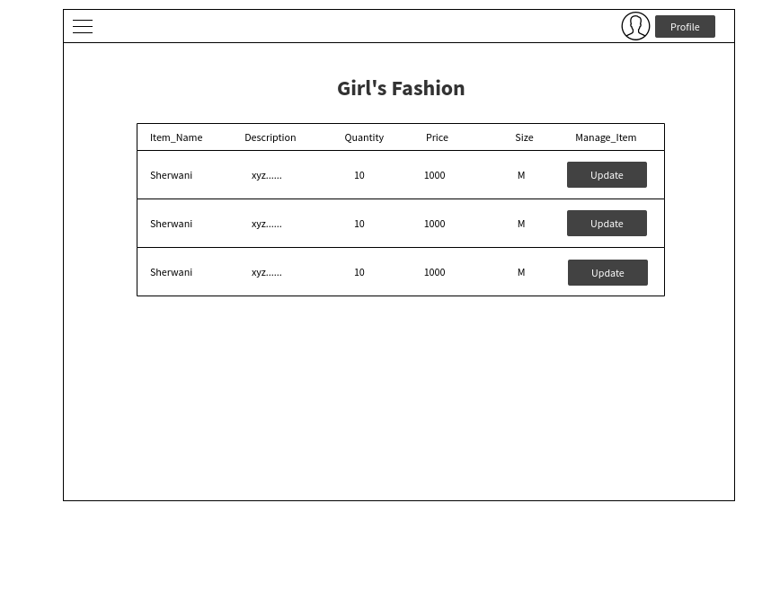

Figure 48: View Item Girl(Admin)

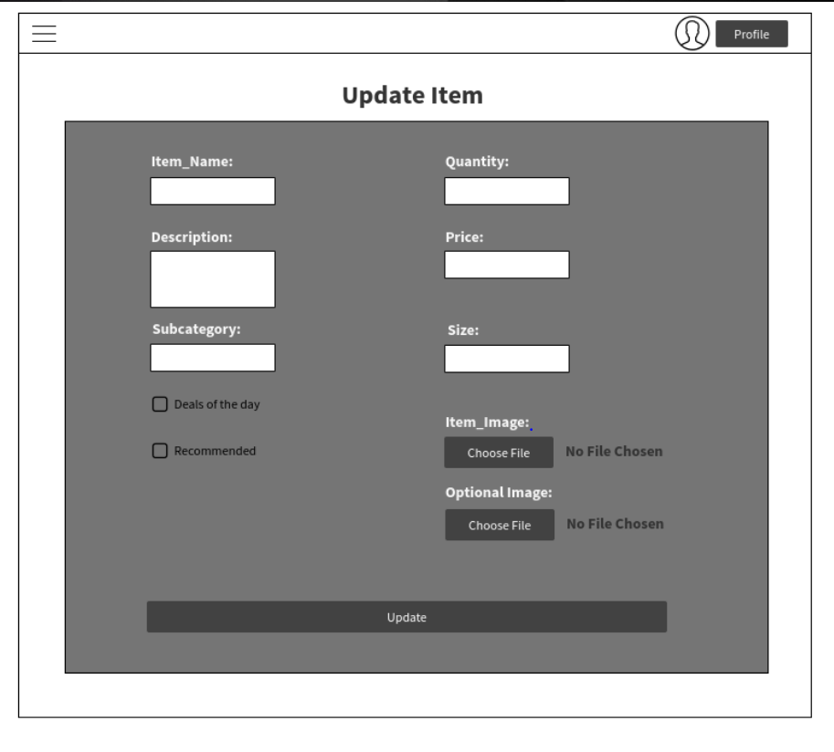

Figure 49: Update Item

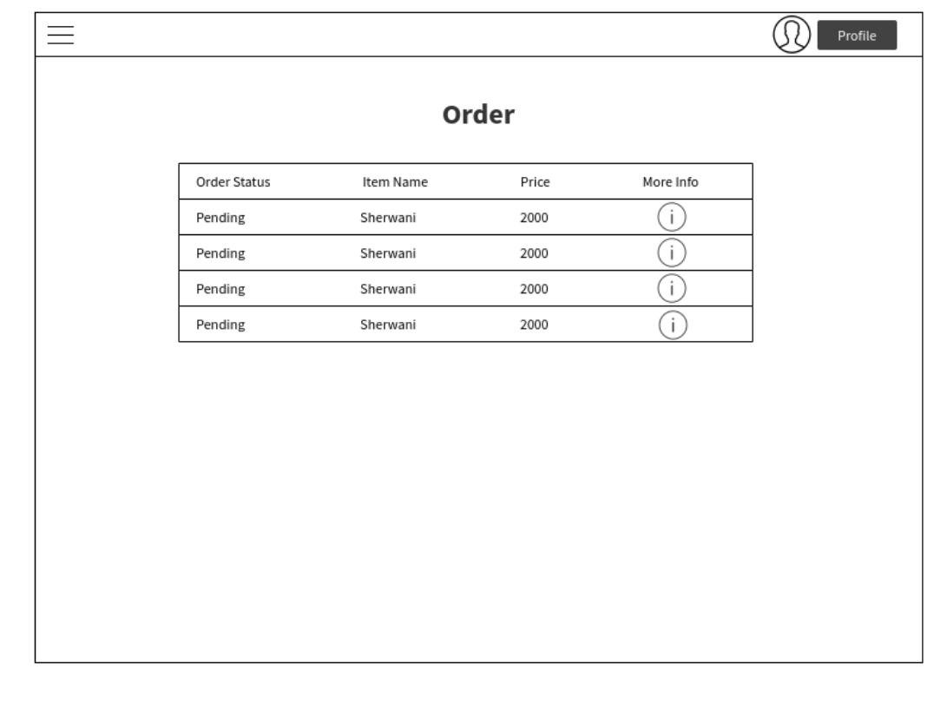

Figure 50: Current Orders(Admin)

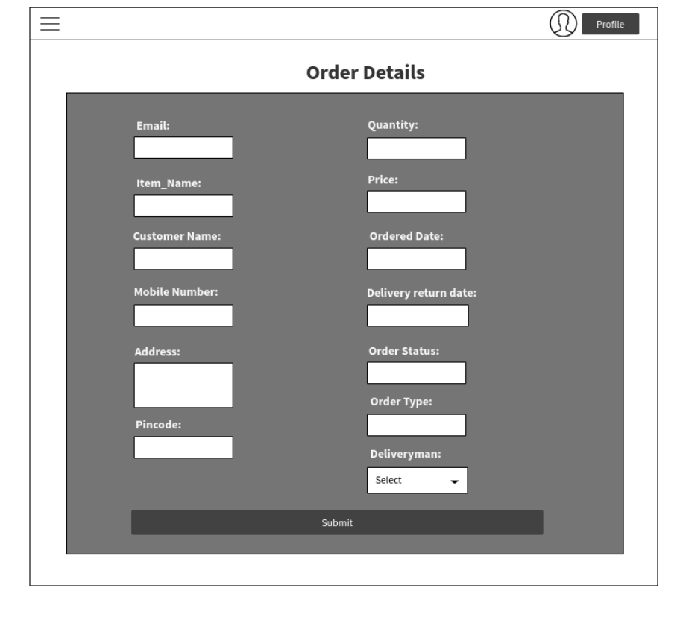

Figure 51: Order Details(Admin)

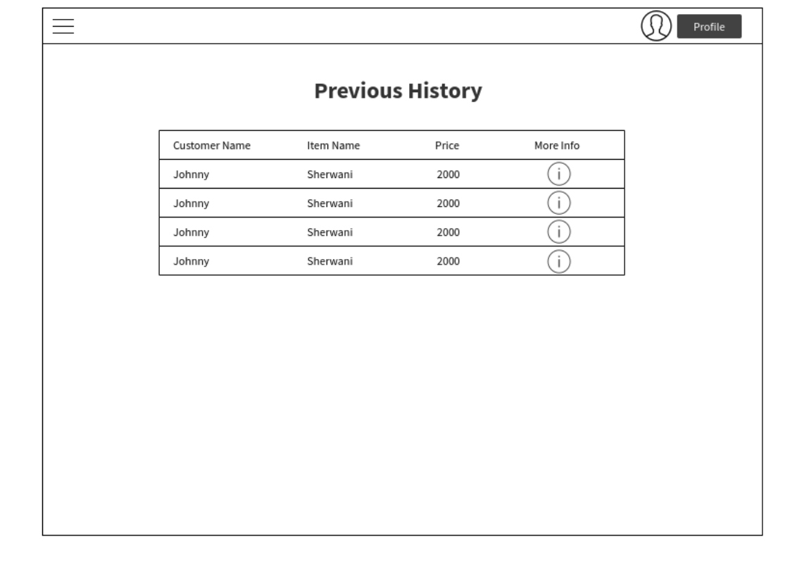

Figure 52: Previous History(Admin)

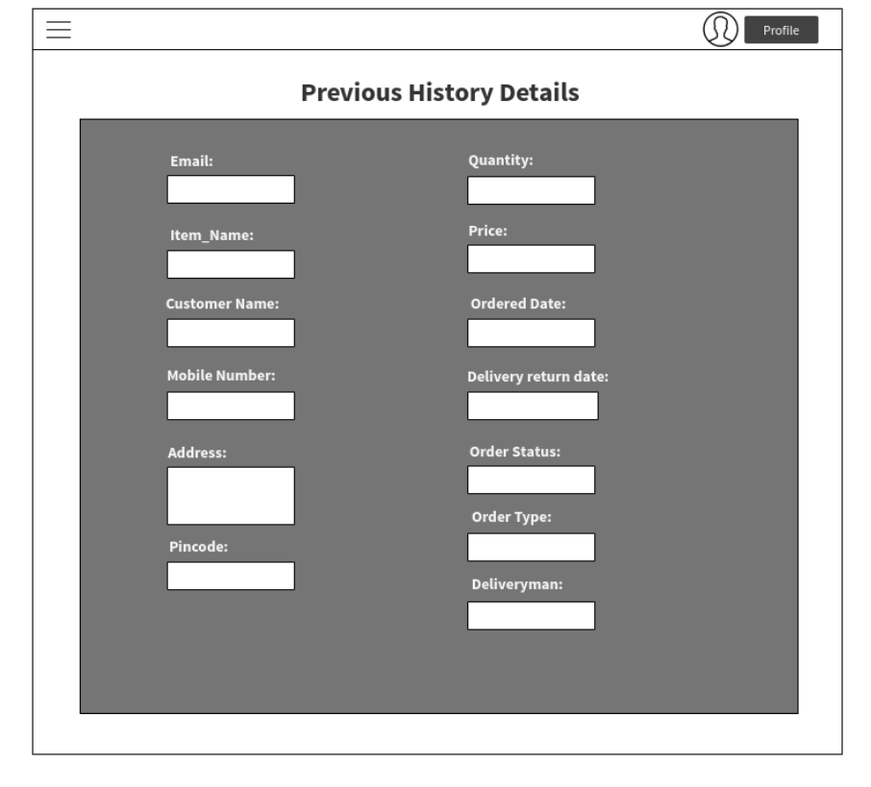

Figure 53: Previous History Details(Admin)

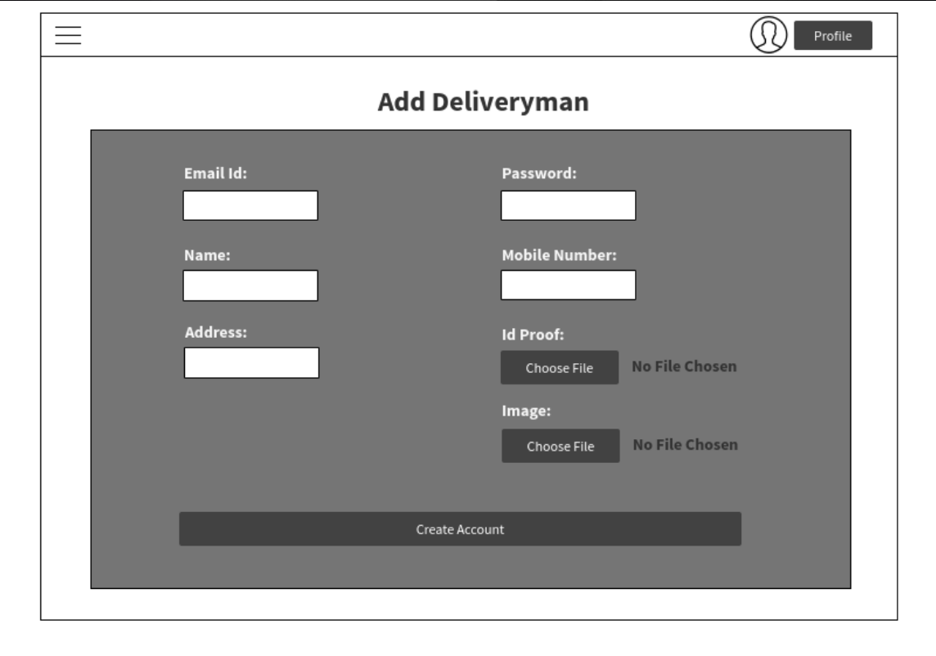

Figure 54: Add Deliveryman

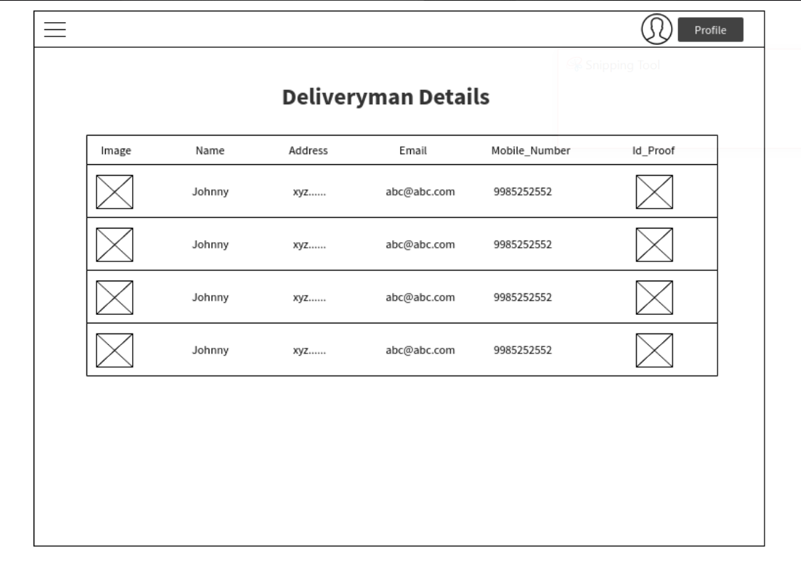

Figure 55: Deliveryman Details

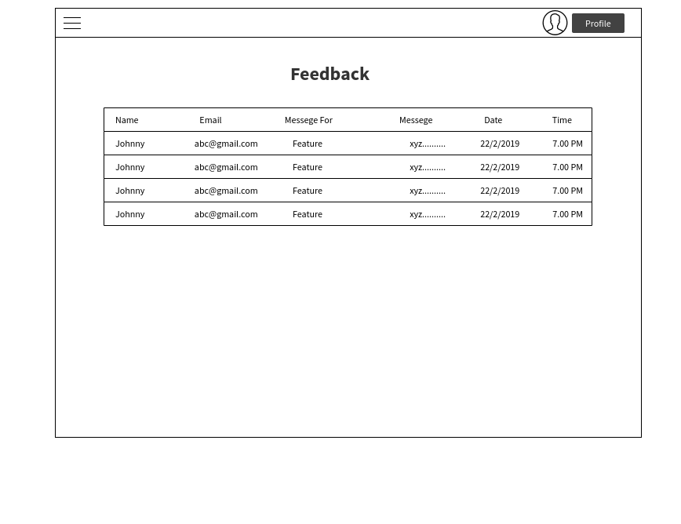

Figure 56: Feedback

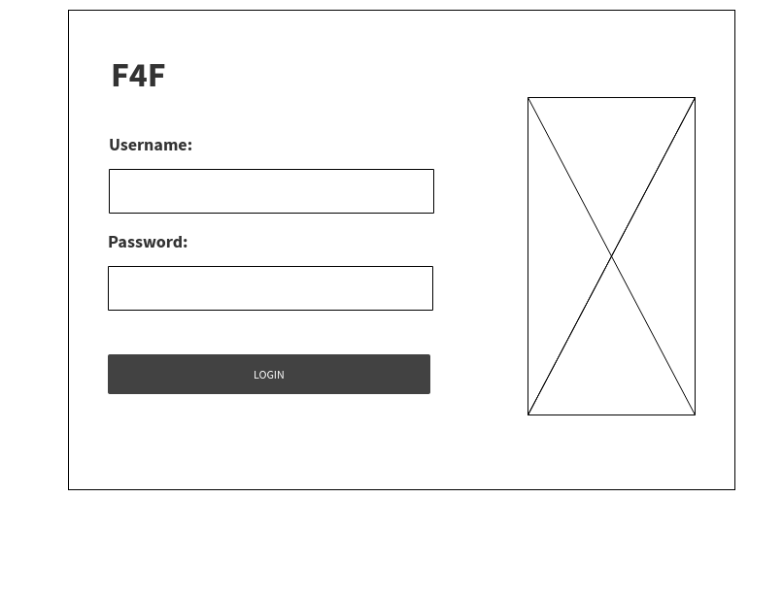

Figure 57: Deliveryman Login

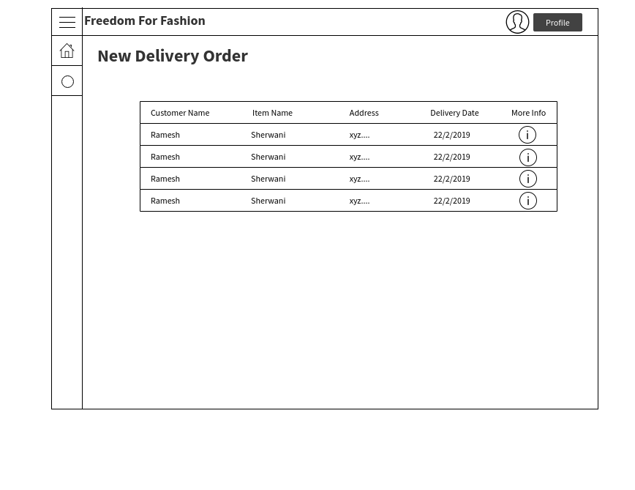

Figure 58: Delivery Order (Deliveryman)

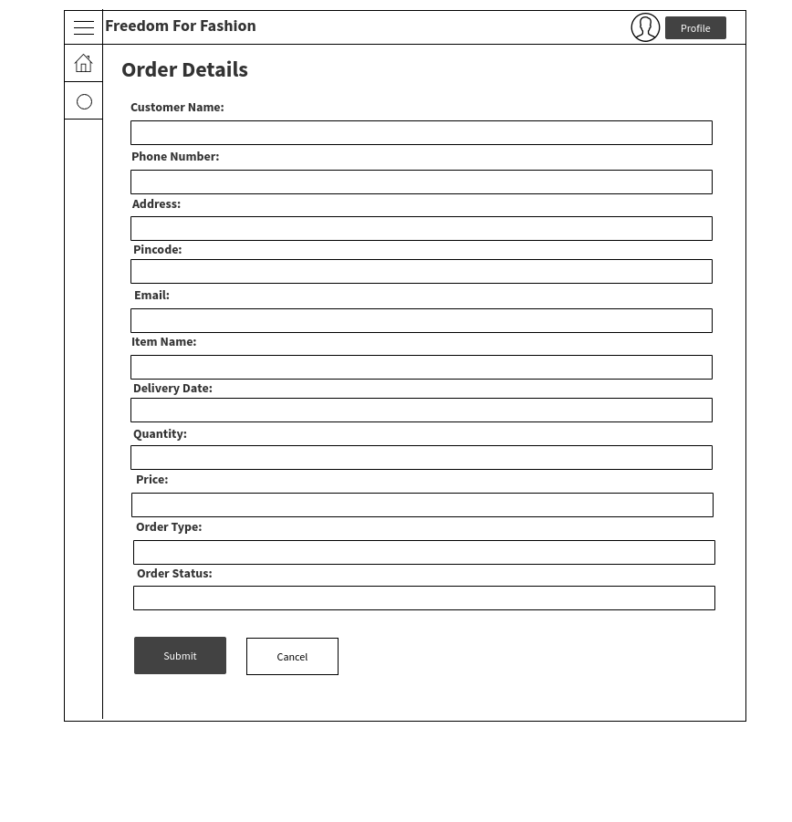

Figure 59: Order Details – Delivery Order (Deliveryman)

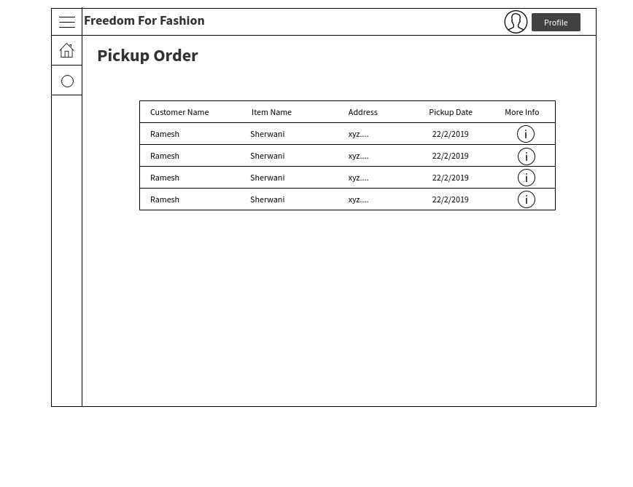

Figure 60 : Pickup Order (Deliveryman)



Figure 61: Order Details – Pickup Order (Deliveryman)

## TimeLine Chart

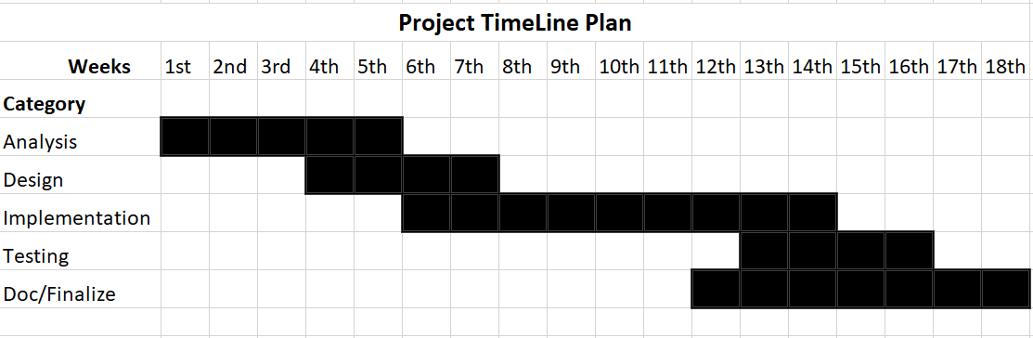

Table 12: TimeLine Chart

# IMPLEMENTATION

## Implementation Environment

## 

## TOOLS

* Visual Studio Code
* Node.js
* Browsers (Chrome, Mozilla, Opera)
* Draw.io
* Lighthouse
* Microsoft Office

## TECHNOLOGIES

|  |  |  |
| --- | --- | --- |
| Main Technology | **:** | **PWA** |
| Language | : | HTML, JavaScript |
| Database | : | NO SQL |
| Query Language | : | Real-time Database API/ Firebase |
| Others | : | CSS, jQuery |

Table 13: Implementation Environment

## Module Specification

**End-users Modules**

Below is the modules list of the end users i.e. Customers or users.

|  |  |
| --- | --- |
| Modules | Description |
| Login | The user has to login into the system through gmail or mobile number. |
| Update Details | In this User can fill his personal details and update it. |
| Deals Of The Day | In this User will get deals of the days which was sort-listed by admin. |
| Recommended | Some items will be displayed by admin to user according admin’s choice. |
| Men/Women/Kids Fashion | In this customer can rent items according these categories. |
| Send Feedback | Here customer can give feedback . |
| Checkout | After adding items into the cart customer can check personal details and total amount and order details. |
| Invoice | After completing order user will get whole details in this page. |
| Order History | In this user can check their previous order history. |

Table 14: End Users Module specification

**Admin Modules**

Below is the modules list for Admin:

|  |  |
| --- | --- |
| Modules | Description |
| Login | Admin has to login into the application to use it further. |
| Manage Item | Admin can add, update and remove items. |
| Manage Delivery | Admin can add deliveryman and assign deliveryman for delivery. |
| View Orders | Admin can view current and previous order. |
| View Feedback | Can view list of feedbacks given by users. |

Table 15: Admin Module specification

Deliveryman Module specification

|  |  |
| --- | --- |
| Modules | Description |
| Delivery Orders | Can view delivery details and can update delivery status. |
| Pickup Orders | Can view Pickup details and can update delivery status. |

## Security Features

**Firebase Security Features**

Firebase Realtime Database Rules determine who has read and write access to your database, how your data is structured, and what indexes exist. These rules live on the Firebase servers and are enforced automatically at all times. Every read and write request will only be completed if your rules allow it. By default, your rules do not allow anyone access to your database. This is to protect your database from abuse until you have time to customize your rules or set up authentication.

The Firebase Realtime Database provides a full set of tools for managing the security of your app. These tools make it easy to authenticate your users, enforce user permissions, and validate inputs.

Firebase-powered apps run more client-side code than those with many other technology stacks. Therefore, the way we approach security may be a bit different than you're used to.

### Authentication:

A common first step in securing your app is identifying your users. This process is called authentication. You can use Firebase Authentication to have users to sign in to your app. Firebase Authentication includes drop-in support for common authentication methods like Google and Facebook, as well as email and password login, anonymous login, and more.

User identity is an important security concept. Different users have different data, and sometimes they have different capabilities. For example, in a chat application, each message is associated with the user that created it. Users may also be able to delete their own messages, but not messages posted by other users.

### Authorization:

Identifying your user is only part of security. Once you know who they are, you need a way to control their access to data in your database. Firebase Database Rules allow you to control access for each user.

The Firebase Database Rules include built-in variables and functions that allow you to refer to other paths, server-side timestamps, authentication information, and more.

### Data validation:

The Firebase Realtime Database is schemaless. This makes it easy to change things as you develop, but once your app is ready to distribute, it's important for data to stay consistent. The rules language includes a .validate rule which allows you to apply validation logic using the same expressions used for .read and .write rules. The only difference is that **validation rules do not cascade**, so all relevant validation rules must evaluate to true in order for the write to be allowed.

(Security Features, 2002)

## Coding Standards

Coding standards define a programming style. A coding standard does not usually concern itself with wrong or right in a more abstract sense. It is simply a set of rules and guidelines for the formatting of source code.

The Coding standards are used to make sure that the names used in the project are used in a most relevant form. All the attributes have unique name which are self-explanatory. The Ids and names used for different methods and functions are different resembling their work. Methods are stored in different files for procedural structure with true concepts of Object-Oriented to a certain standard

(Steave, 2007)

## Coding Sample

**View Men’s Fashion Data list (js file)**

var databaseRef = firebase.database().ref('item');

document.getElementById('fileButton').onchange = function(event){

selectedFile = event.target.files[0];

}

// var databaseRef_women = firebase.database().ref();

firebase.auth().onAuthStateChanged(function(user) {

var url_string = window.location.href;

var url = new URL (url_string);

var id = url.searchParams.get('id');

var uid = url.searchParams.get('uid');

databaseRef.child('Men').child(id).on('value',function(update_snapshot){

document.getElementById('item_name').value = update_snapshot.child('item_name').val();

document.getElementById('item_description').value = update_snapshot.child('item_description').val();

document.getElementById('item_subcategory').value = update_snapshot.child('item_subcategory').val();

document.getElementById('item_quantity').value = update_snapshot.child('item_quantity').val();

document.getElementById('item_price').value = update_snapshot.child('item_price').val();

document.getElementById('item_size').value = update_snapshot.child('item_size').val();

});

databaseRef.child('Men').child(id).child('deals_of_the_day').on('value',function(update_checkbox_snapshot){

var update_checkbox = update_checkbox_snapshot.val();

console.log(update_checkbox);

if(update_checkbox == true)

{

var check=document.getElementsByTagName('input');

for(var i=0;i<check.length;i++){

if(check[i].type=='checkbox')

{

document.getElementById('dod').checked=true;

}

else

{

document.getElementById('dod').removeAttribute('checked');

}

}

}

else

{

}

});

firebase.auth().onAuthStateChanged(function(user) {

databaseRef.child('Men').child(id).child('recommended').on('value',function(update_checkbox_snapshot_rec){

var update_checkbox_rec = update_checkbox_snapshot_rec.val();

console.log(update_checkbox_rec);

if(update_checkbox_rec == true)

{

var check_rec=document.getElementsByTagName('input');

for(var i=0;i<check_rec.length;i++){

if(check_rec[i].type=='checkbox')

{

document.getElementById('rec').checked=true;

}

else

{

document.getElementById('rec').removeAttribute('checked');

}

}

}

else

{

}

});

});

document.getElementById('btn_insertname').onclick = function(){

var item_name = document.getElementById('item_name').value;

var item_description = document.getElementById('item_description').value;

var item_subcategory = document.getElementById('item_subcategory').value;

var deals_of_the_day = document.getElementById('dod').checked;

var recommended = document.getElementById('rec').checked;

var item_quantity = document.getElementById('item_quantity').value;

var item_price = document.getElementById('item_price').value;

var item_size = document.getElementById('item_size').value;

// console.log(email_wd);

var filename = selectedFile.name;

var storageRef = firebase.storage().ref('ClothingPictures/' + selectedFile.name);

var uploadTask = storageRef.put(selectedFile);

uploadTask.on('state_changed',

function(snapshot){

var progress = (snapshot.bytesTransferred / snapshot.totalBytes) * 100;

alert('Upload Progress : '+progress+'%');

},function(error){

},function(){

uploadTask.snapshot.ref.getDownloadURL().then(function(downloadURL){

databaseRef.child('Men').child(id).update({

item_name : item_name,

item_description : item_description,

item_subcategory : item_subcategory,

deals_of_the_day : deals_of_the_day,

recommended : recommended,

item_quantity : item_quantity,

item_price : item_price,

item_size : item_size,

optional_image : downloadURL

});

alert('Data Updated Successfully');

});

});

};

});

# TESTING

Software testing is the process of evaluation a software item to detect differences between given input and expected output. Also to assess the feature of A software item. Testing assesses the quality of the product. Software testing is a process that should be done during the development process. In other words software testing is a verification and validation process.

(Testing, 1996)

## Test Plan

The test plan is to check all functionality according to SRS defined requirements. Apart from that, the current market needs to be attained at every point of time. We need to make necessary changes if any are required. We need to make sure that all the objectives for which the software was build is properly attained while the system is secure and easy to use. The system also has to be sustainable. Test planning, the most important activity to ensure that there is initially a list of tasks and milestones in a baseline plan to track the progress of the project. It also defines the size of the test effort.

**Test Planning Activities:**

* To determine the scope and the risks that need to be tested and that are NOT to be tested.
* Documenting Test Strategy.
* Making sure that the testing activities have been included.
* Deciding Entry and Exit criteria.
* Evaluating the test estimate.
* Planning when and how to test and deciding how the test results will be evaluated, and defining test exit criterion.
* The Test artefacts delivered as part of test execution.
* Defining the management information, including the metrics required and defect resolution and risk issues.
* Ensuring that the test documentation generates repeatable test assets.

(H.W.L, 1996)

## Test Strategy

To perform testing in a planned and systematic manner, software testing strategy is developed. A testing strategy is used to identify the levels of testing which are to be applied along with the methods, techniques, and tools to be used during testing. Developing a test strategy, which efficiently meets the requirements of an organization, is critical to the success of software development in that organization. Therefore, a software testing strategy should contain complete information about the procedure to perform testing and the purpose and requirements of testing. The choice of software testing strategy is highly dependent on the nature of the developed software. For example, if the software is highly data intensive then a strategy that checks structures and values properly to ensure that all inputs given to the software are correct and complete should be developed. Similarly, if it is transaction intensive then the strategy should be such that it is able to check the flow of all the transactions. The design and architecture of the software are also useful in choosing testing strategy. A number of software testing strategies are developed in the testing process. All these strategies provide the tester a template, which is used for testing. (test strategy, 1993)

Below are the types of testing strategy:

**Graphical User Interface**

The graphical user interface (GUI), is a type of user interface that allows users to interact with electronic devices through graphical icons and visual indicators such as secondary notation, instead of text-based user interfaces, typed command labels or text navigation. GUIs were introduced in reaction to the perceived steep learning curve of command-line interfaces (CLIs), which require commands to be typed on a computer keyboard. (W3C, 1993)

**Usability Testing**

Usability testing is a method used in user-centered interaction design to estimate a product by testing it on users. This can be seen as a unique usability practice, since it offers direct input on how actual users use the system. This is in contrast with usability inspection methods where experts use different methods to evaluate a user interface without concerning users. (ut, 2018)

**Functional Testing**

Functional testing is a quality assurance (QA) process and a type of black-box testing that bases its test cases on the specifications of the software component under test. Functions are tested by giving them input and examining the output, and internal program structure is rarely considered (unlike white-box testing). Functional testing frequently defines what the system actually does. (bradford, 2009)

## Test Methods

There are two basics of software testing: blackbox testing and whitebox testing.

**Blackbox Testing**

Black box testing is a testing technique that overlooks the internal mechanism of the system and focuses on the output generated. It is also called functional testing.

**Whitebox Testing**

White box testing is a technique that takes into account the internal mechanism of a system. It is also called structural testing and glass box testing.

Black box testing is mainly used for validation while white box testing is used for verification.

Types of testing strategies are:

**Unit testing**

Here in the project we have performed Unit testing. We have tested the most basic parts of codes by dividing them into small units

**Component testing**

Component testing also known as module or program testing. It’s similar to unit testing but contains a higher level of integration. Here modules of the software were tested for defects to verify their individual function.

**Integration testing**

After performing the unit and component testing, integration testing was performed. Here the modules were integrated together and were tested to make sure that their methods and functions perform properly

**Functional Testing**

Functional testing was done to ensure that the specified functionality required in the system requirements works properly.

**System testing**

Components of a project were tested as a whole in different mobile phones with this method. It is one of the final tests in the process. It determines whether the system functions as per the requirements.

**Acceptance testing**

In this test the client tests software to find out if the developer has created the program to desired specifications. This testing was conducted by our external guide from Enlighten Infosystems.

**Security testing**

This measures the software’s ability to protect users’ security. This means authorization functions, authentication, confidentiality, integrity, availability, and non-repudiation.

(test methods, 1970)

## Test Cases

|  |  |
| --- | --- |
| ID | FFTC1 |
| Module | User Login |
| Dependency | User should have Gmail account or any other email account and Mobile Number |
| Variables | User Email, Password or Mobile number |
| Precondition | User should have Gmail account or any other email account and Mobile Number |
| Action | User should enter email id and password |
| Expected Result | 1.If user is logging in first time it will redirect to the welcome details page  2.If user already login once it will be redirected to home page |
| Actual Result | 1.User is logging in first time redirected to the welcome details page  2.User already login once has redirected to home page |
| Failure Condition | If Incorrect Email and Password or Mobile Number show message of incorrect Email Id and Password or Mobile Number |

Table 16: Test Case: User Login

|  |  |
| --- | --- |
| ID | FFTC2 |
| Module | Update Details |
| Dependency | User should Login |
| Variables | First Name, Last Name, Mobile Number, Address, Pin code, E-Mail |
| Precondition | User should Login |
| Action | User should update enter Name, Address, Phone No., Shop Name, Email, Password |
| Expected Result | If user change any details, it will update detail |
| Actual Result | Updated Details |

Table 17: Test Case: Update Details

|  |  |
| --- | --- |
| ID | FFTC3 |
| Module | Men’s Clothing |
| Dependency | User should Login |
| Variables | Add to cart |
| Precondition | User should Login |
| Action | User should click on item which he/she wants to rent |
| Expected Result | Item added in cart successfully |
| Actual Result | Item added in cart successfully |
| Failure Condition | - |

Table 18: Test Case: Men’s Clothing

|  |  |
| --- | --- |
| ID | FFTC4 |
| Module | Women’s Clothing |
| Dependency | User should Login |
| Variables | Add to cart |
| Precondition | User should Login |
| Action | User should click on item which he/she wants to rent |
| Expected Result | Item added in cart successfully |
| Actual Result | Item added in cart successfully |
| Failure Condition | - |

Table 19: Test Case: Women’s Clothing

|  |  |
| --- | --- |
| ID | FFTC5 |
| Module | Kids Clothing |
| Dependency | User should Login |
| Variables | Add to cart |
| Precondition | User should Login |
| Action | User should click on item which he/she wants to rent |
| Expected Result | Item added in cart successfully |
| Actual Result | Item added in cart successfully |
| Failure Condition | - |

Table 20: Test Case: Kid’s Clothing

|  |  |
| --- | --- |
| ID | FFTC6 |
| Module | Send Feedback |
| Dependency | User should Login |
| Variables | Name, Email, Messege |
| Precondition | User should Login |
| Action | User should enter Name , Email And Messege |
| Expected Result | Feedback Sent Successfully |
| Actual Result | Feedback Sent Successfully |
| Failure Condition | If Incorrect or Empty any detail show message of incorrect detail information or please fill this. |

Table 21: Test Case: Send Feedback

|  |  |
| --- | --- |
| ID | FFTC7 |
| Module | Checkout |
| Dependency | User should Login |
| Variables | Quantity and Days(User data will be already auto filled ) |
| Precondition | User should Login |
| Action | User should enter quantity and days(User can update that data if they want) |
| Expected Result | Checkout |
| Actual Result | Checkout |
| Failure Condition | If cannot enter number of days, it show message of please select days. |

Table 22: Test Case: Checkout

|  |  |
| --- | --- |
| ID | FFTC8 |
| Module | Invoice |
| Dependency | User should Login and Checkout |
| Variables | - |
| Precondition | User should Login and Checkout |
| Action | - |
| Expected Result | Invoice |
| Actual Result | Invoice |
| Failure Condition | - |

Table 23: Test Case: Invoice

|  |  |
| --- | --- |
| ID | FFTC9 |
| Module | Admin Login |
| Dependency | Admin should have particular email and password for login |
| Variables | Admin Email and Password |
| Precondition | Admin should have particular email and password for login |
| Action | Admin should enter email and password |
| Expected Result | Home Page |
| Actual Result | Home Page |
| Failure Condition | - |

Table 24: Test Case: Admin Login

|  |  |
| --- | --- |
| ID | FFTC10 |
| Module | Add Item |
| Dependency | Admin should login |
| Variables | Item name, Description, category, quantity, price, size, image |
| Precondition | Admin should login |
| Action | Admin should enter Item name, Description, category, price, size,image |
| Expected Result | Item Added Successfully |
| Actual Result | Item Added Successfully |
| Failure Condition | If admin forgot to enter any details, it will show message of please fill this detail |

Table 25: Test Case: Add Item(Admin)

|  |  |
| --- | --- |
| ID | FFTC12 |
| Module | View Item(Men’s Fashion) |
| Dependency | Admin should login |
| Variables | Update And Inactive |
| Precondition | Admin should login |
| Action | Admin can update details of item or inactive item |
| Expected Result | Item updated successfully or item inactived |
| Actual Result | Item updated successfully or item inactived |
| Failure Condition | If admin forgot to enter any details, it will show message of please fill this detail |

Table 26: Test Case: View Item(Men’s Fashion)

|  |  |
| --- | --- |
| ID | FFTC13 |
| Module | View Item(Women’s Fashion) |
| Dependency | Admin should login |
| Variables | Update And Inactive |
| Precondition | Admin should login |
| Action | Admin can update details of item or inactive item |
| Expected Result | Item updated successfully or item inactived |
| Actual Result | Item updated successfully or item inactived |
| Failure Condition | If admin forgot to enter any details, it will show message of please fill this detail |

Table 27: Test Case: View Item(Women’s Fashion)

|  |  |
| --- | --- |
| ID | FFTC14 |
| Module | View Item(Boy’s Fashion) |
| Dependency | Admin should login |
| Variables | Update And Inactive |
| Precondition | Admin should login |
| Action | Admin can update details of item or inactive item |
| Expected Result | Item updated successfully or item inactived |
| Actual Result | Item updated successfully or item inactived |
| Failure Condition | If admin forgot to enter any details, it will show message of please fill this detail |

Table 28: Test Case: View Item(Boy’s Fashion)

|  |  |
| --- | --- |
| ID | FFTC15 |
| Module | View Item(Men’s Fashion) |
| Dependency | Admin should login |
| Variables | Update And Inactive |
| Precondition | Admin should login |
| Action | Admin can update details of item or inactive item |
| Expected Result | Item updated successfully or item inactived |
| Actual Result | Item updated successfully or item inactived |
| Failure Condition | If admin forgot to enter any details, it will show message of please fill this detail |

Table 29: Test Case: View Item(Girl’s Fashion)

|  |  |
| --- | --- |
| ID | FFTC16 |
| Module | Add Deliveryman |
| Dependency | Admin should login |
| Variables | Email id, Name, Address, Password, Mobile number, Idproof, Image |
| Precondition | Admin should login |
| Action | Admin should enter email , address, password, mobile number, id proof and image |
| Expected Result | Deliveryman Added Successfully |
| Actual Result | Deliveryman Added Successfully |
| Failure Condition | If admin forgot to enter any details, it will show message of please fill this detail |

Table 30: Test Case: Add Deliveryman

|  |  |
| --- | --- |
| ID | FFTC17 |
| Module | Deliveryman Details |
| Dependency | Admin should Login |
| Variables | - |
| Precondition | Admin should Login |
| Action | - |
| Expected Result | Deliveryman Details |
| Actual Result | Deliveryman Details |
| Failure Condition | - |

Table 31 : Test Case: Deliveryman Details

|  |  |
| --- | --- |
| ID | FFTC18 |
| Module | Current Status |
| Dependency | Admin should Login |
| Variables | Info Button |
| Precondition | Admin should Login |
| Action | Admin should click on info button |
| Expected Result | Order Details |
| Actual Result | Order Details |
| Failure Condition | - |

Table 32 : Test Case: Current Status

|  |  |
| --- | --- |
| ID | FFTC19 |
| Module | Order details |
| Dependency | Admin should Login |
| Variables | Set Deliveryman |
| Precondition | Admin should Login |
| Action | Admin should Select Deliveryman |
| Expected Result | Order Sent successfully |
| Actual Result | Order Sent successfully |
| Failure Condition | If Admin forgot to set deliveryman it will show message of please select deliveryman. |

Table 33 : Test Case: Order Details

|  |  |
| --- | --- |
| ID | FFTC20 |
| Module | Previous History |
| Dependency | Admin should Login |
| Variables | More info button |
| Precondition | Admin should Login |
| Action | Admin should click on info button |
| Expected Result | Previous Order Details |
| Actual Result | Previous Order Details |
| Failure Condition | - |

Table 34 : Test Case: Previous History

|  |  |
| --- | --- |
| ID | FFTC21 |
| Module | Previous Order Details |
| Dependency | Admin should Login |
| Variables | - |
| Precondition | Admin should Login |
| Action | - |
| Expected Result | Previous Order Details |
| Actual Result | Previous Order Details |
| Failure Condition | - |

Table 35 : Test Case: Previous Order Details

|  |  |
| --- | --- |
| ID | FFTC22 |
| Module | Feedback |
| Dependency | Admin should Login |
| Variables | - |
| Precondition | Admin should Login |
| Action | - |
| Expected Result | Feedback |
| Actual Result | Feedback |
| Failure Condition | - |

Table 36 : Test Case: Feedback

|  |  |
| --- | --- |
| ID | FFTC23 |
| Module | Deliveryman Login |
| Dependency | Deliveryman should have particular email and password for login |
| Variables | Deliveryman Email and Password |
| Precondition | Deliveryman should have particular email and password for login |
| Action | Deliveryman should enter email and password |
| Expected Result | Home Page |
| Actual Result | Home Page |
| Failure Condition | Login Page |

Table 37: Test Case: Deliveryman Login(Deliveryman)

|  |  |
| --- | --- |
| ID | FFTC24 |
| Module | Delivery Order |
| Dependency | Deliveryman should login |
| Variables | More Info Button |
| Precondition | Deliveryman should login |
| Action | Deliveryman should click on more info button |
| Expected Result | Order Details |
| Actual Result | Order Details |
| Failure Condition | - |

Table 38: Test Case: Delivery Order (Deliveryman)

|  |  |
| --- | --- |
| ID | FFTC25 |
| Module | Order Details |
| Dependency | Deliveryman should login |
| Variables | Order Status, Deposit Taken, Any Damage |
| Precondition | Deliveryman should login |
| Action | Deliveryman Should Order Status and should submit |
| Expected Result | Delivery Order |
| Actual Result | Delivery Order |
| Failure Condition | - |

Table 39: Test Case: Order Details(Delivery Order)

|  |  |
| --- | --- |
| ID | FFTC26 |
| Module | Pickup Order |
| Dependency | Deliveryman should login |
| Variables | More Info Button |
| Precondition | Deliveryman should login |
| Action | Deliveryman should click on more info button |
| Expected Result | Order Details |
| Actual Result | Order Details |
| Failure Condition | - |

Table 40: Test Case: Pickup Order (Deliveryman)

|  |  |
| --- | --- |
| ID | FFTC27 |
| Module | Order Details |
| Dependency | Deliveryman should login |
| Variables | Order Status, Deposit Taken, Any Damage |
| Precondition | Deliveryman should login |
| Action | Deliveryman Should Order Status and should submit |
| Expected Result | Pickup Order |
| Actual Result | Pickup Order |
| Failure Condition | - |

Table 41: Test Case: Order Details(Pickup Order)

# SCREENSHOTS

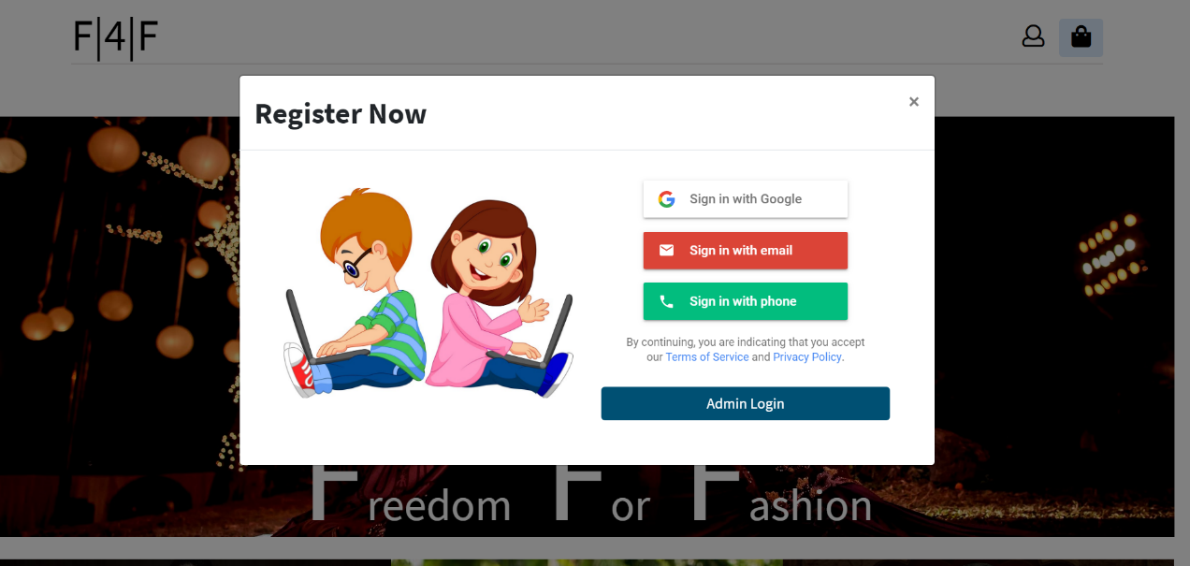

Figure 62 : User Login

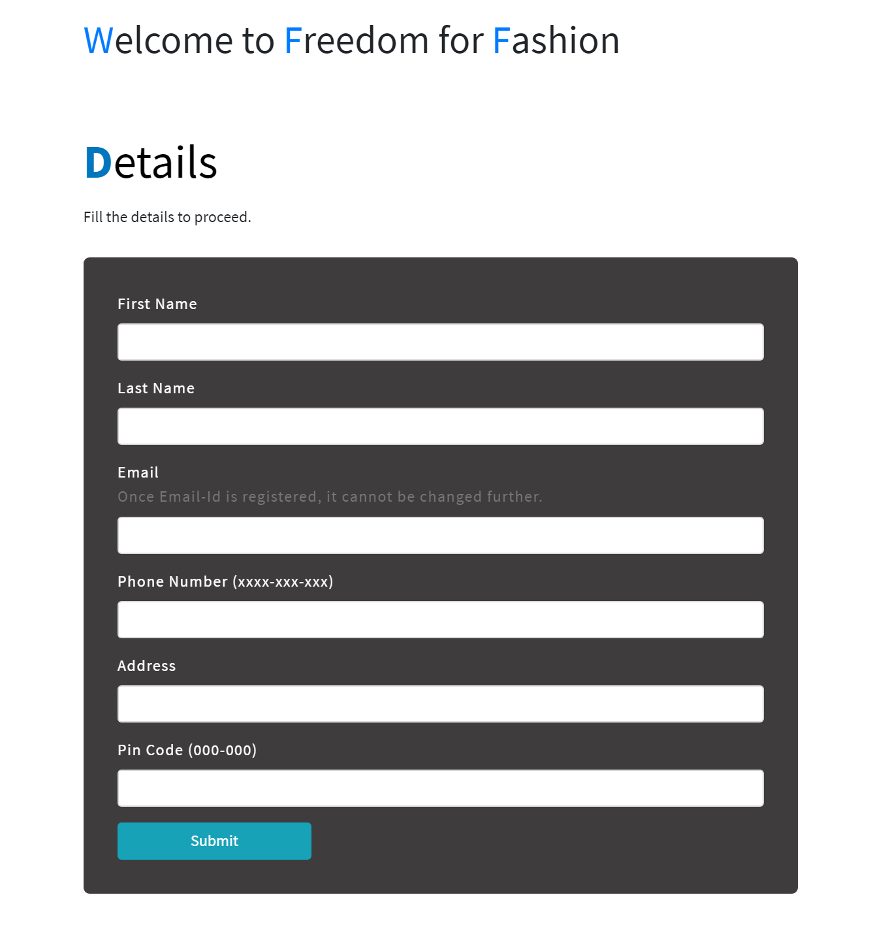

Figure 63: Welcome Details

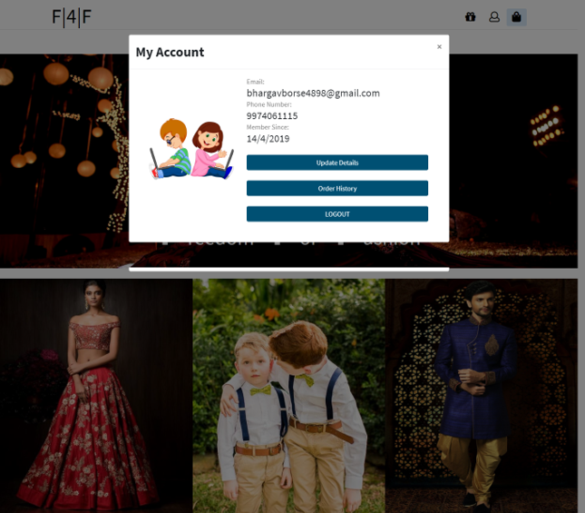

Figure 64: After Login

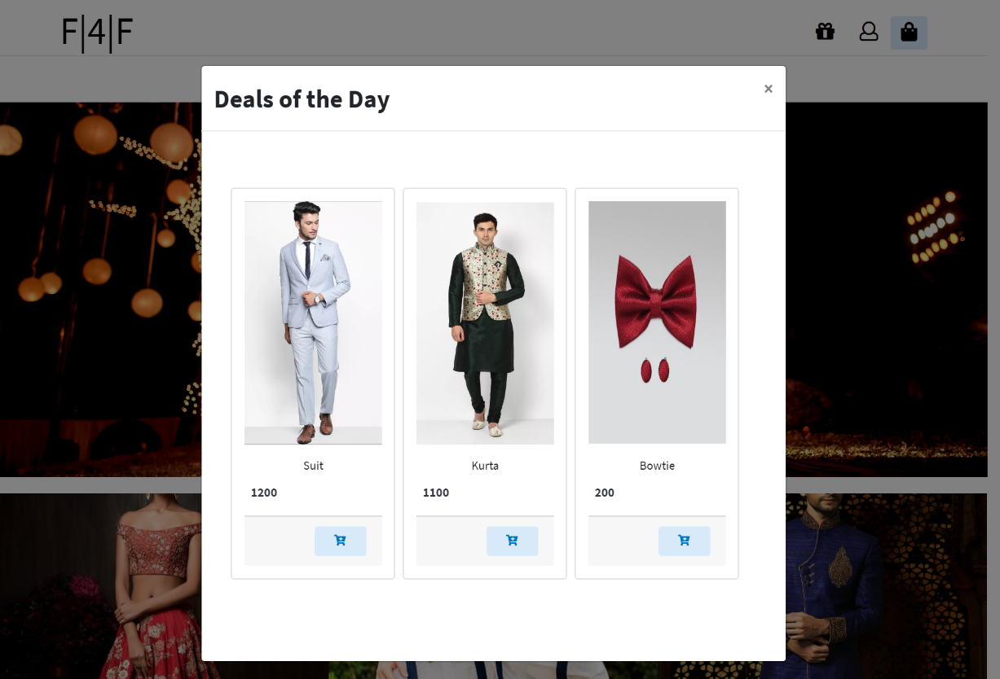

Figure 65: Deals of the Day

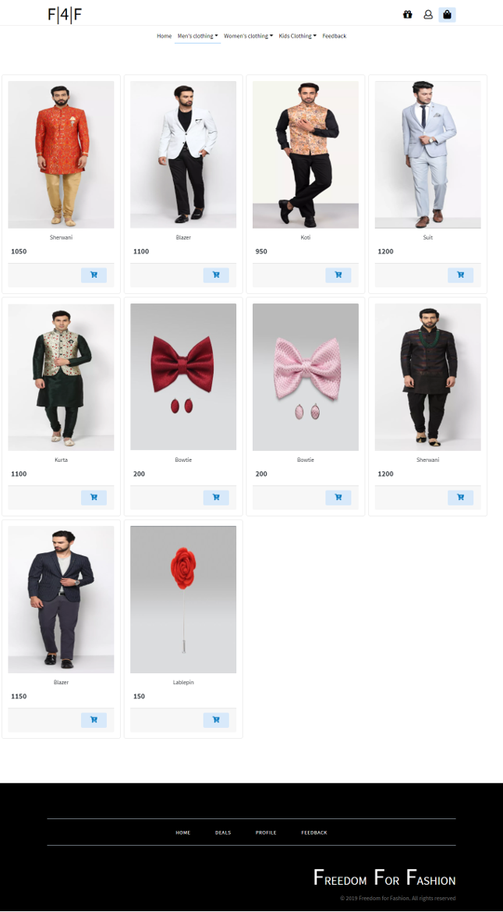

Figure 66: Men’s Clothing

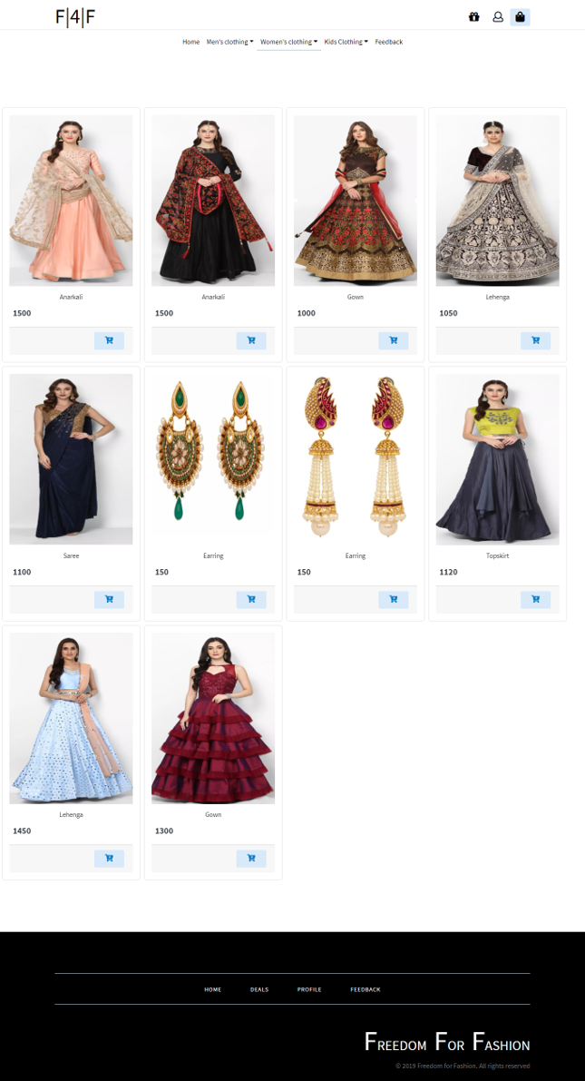

Figure 67: Women’s Clothing

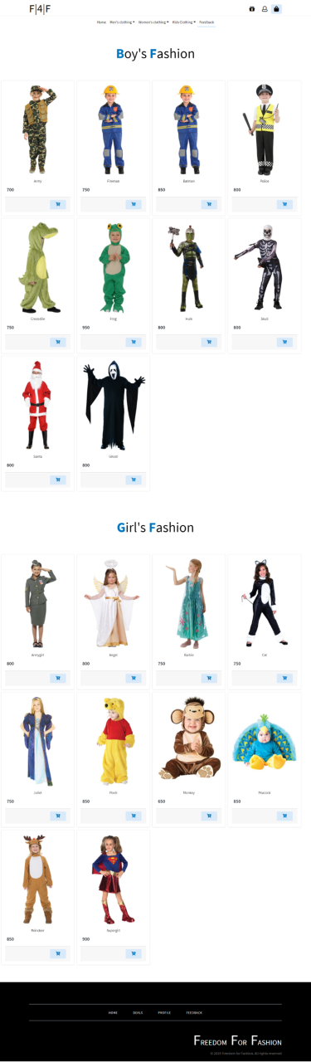

Figure 68: Kid’s Clothing

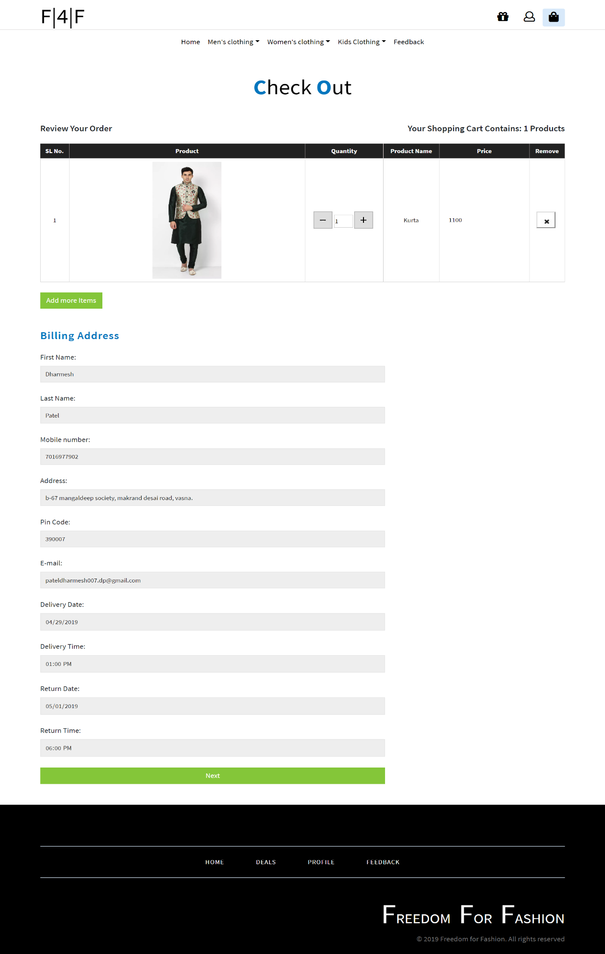

Figure 69: Checkout Page

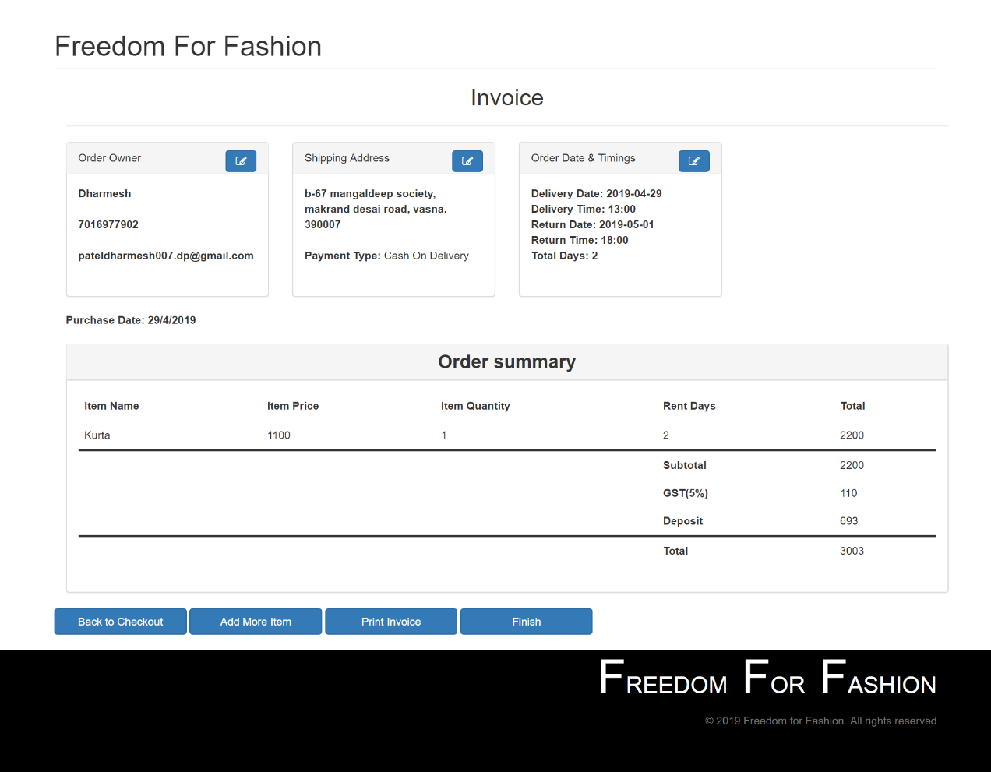

Figure 70: Invoice

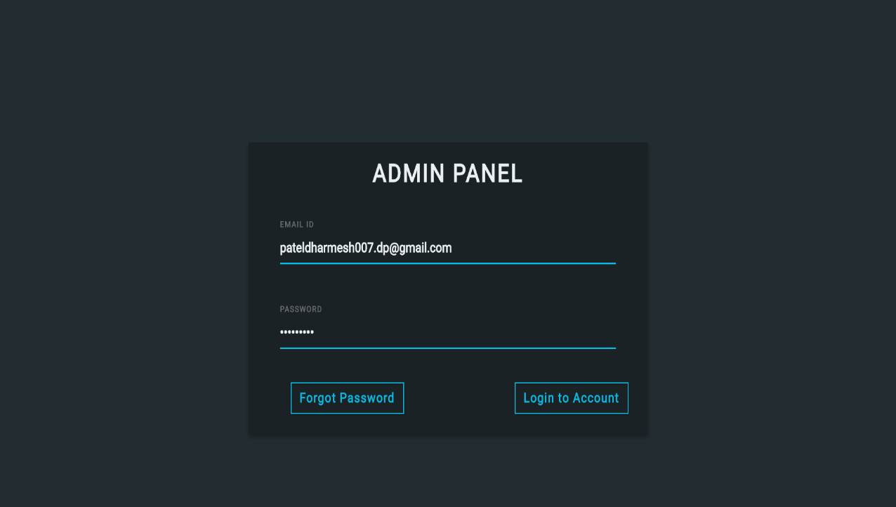

Figure 71: Admin Login

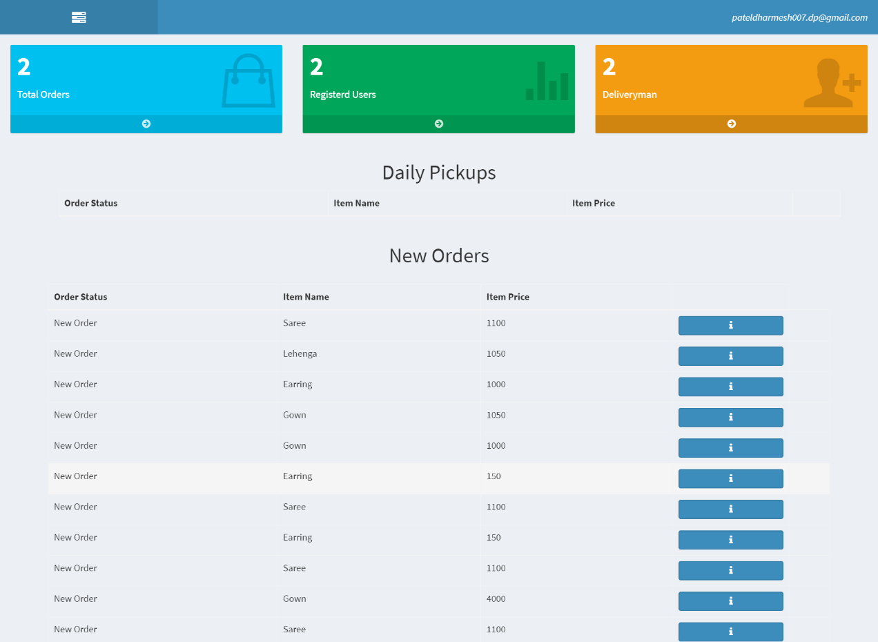

Figure 72: Admin Dashboard

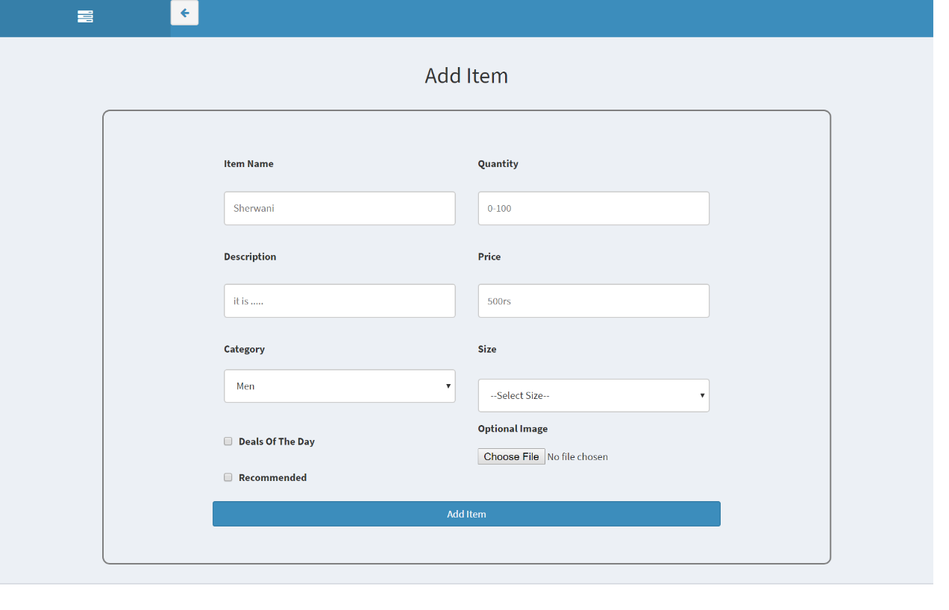

Figure 73: Add Item

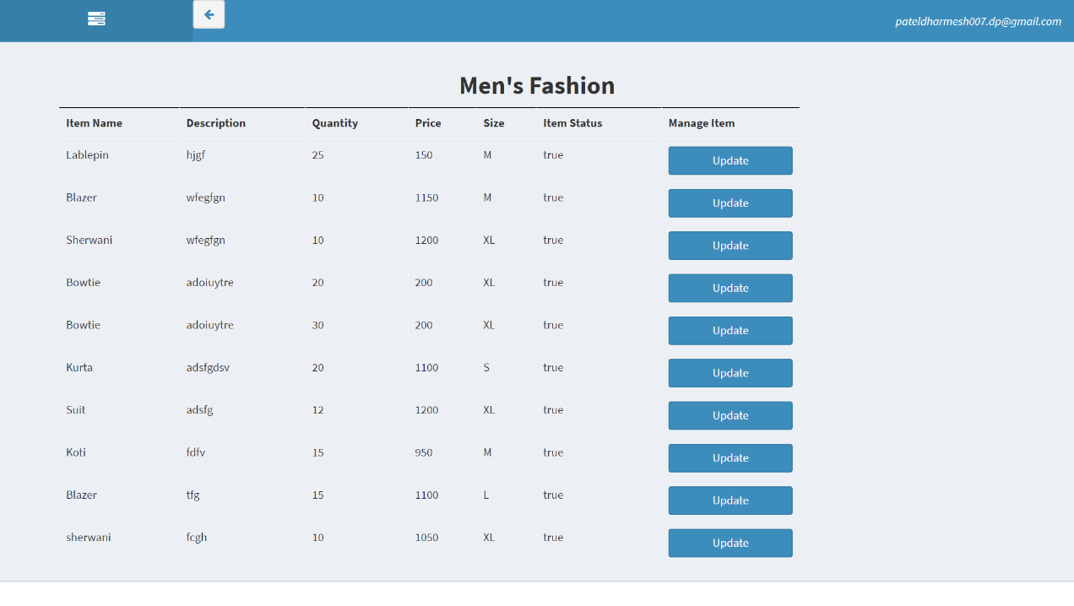

Figure 74: View Item(Men’s Fashion)

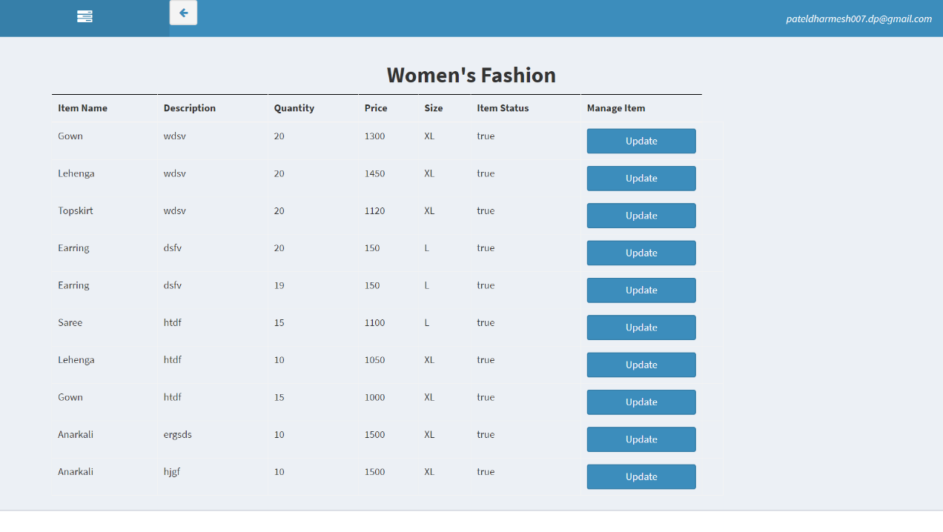

Figure 75: View Item(Women’s Fashion)

# 

Figure 76: View Item(Boy’s Fashion)

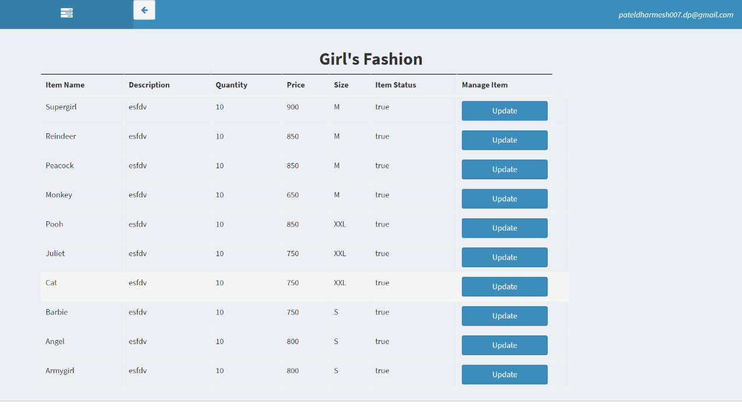

Figure 77: View Item(Girl’s Fashion)

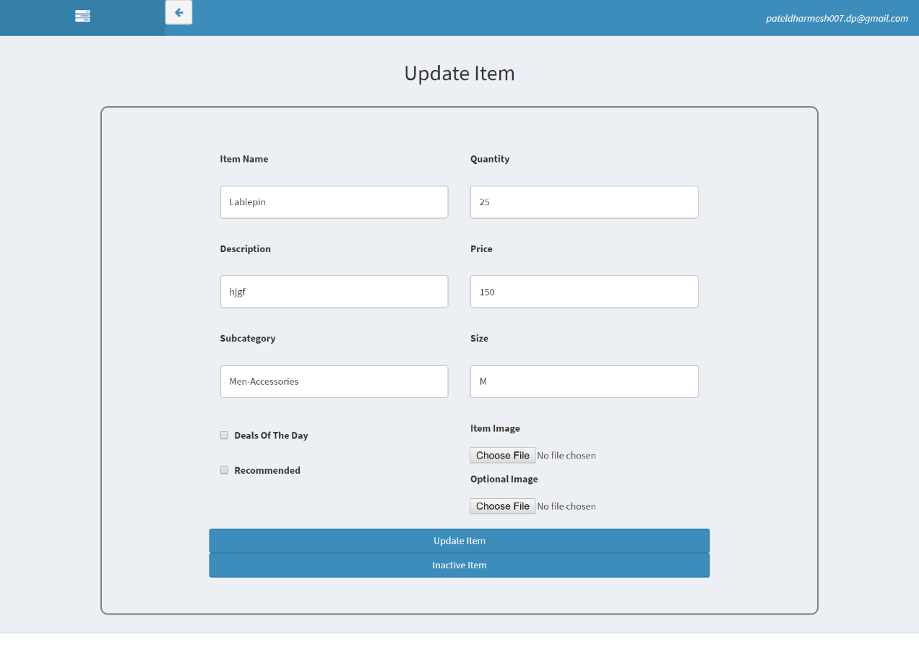

Figure 78: Update Item

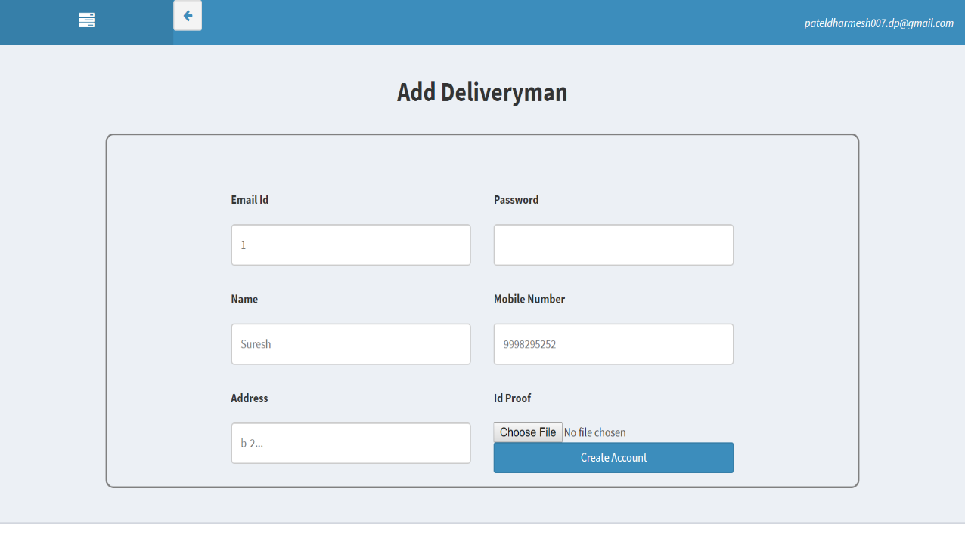

Figure 79: Add Deliveryman

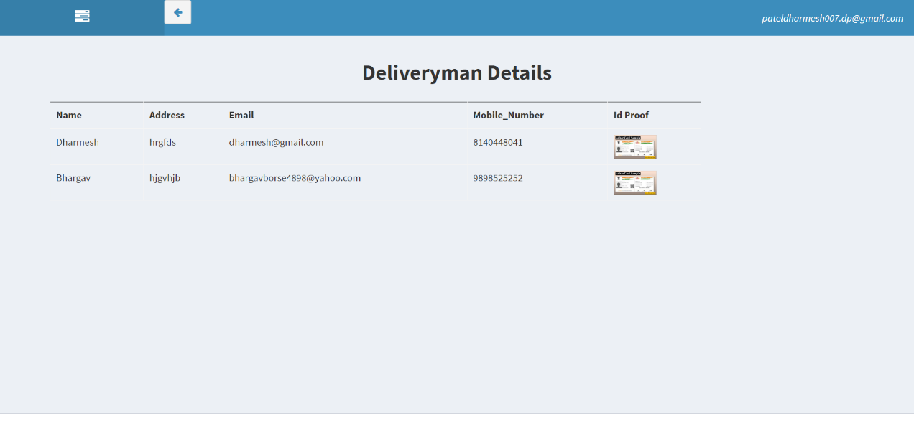

Figure 80: Deliveryman Details

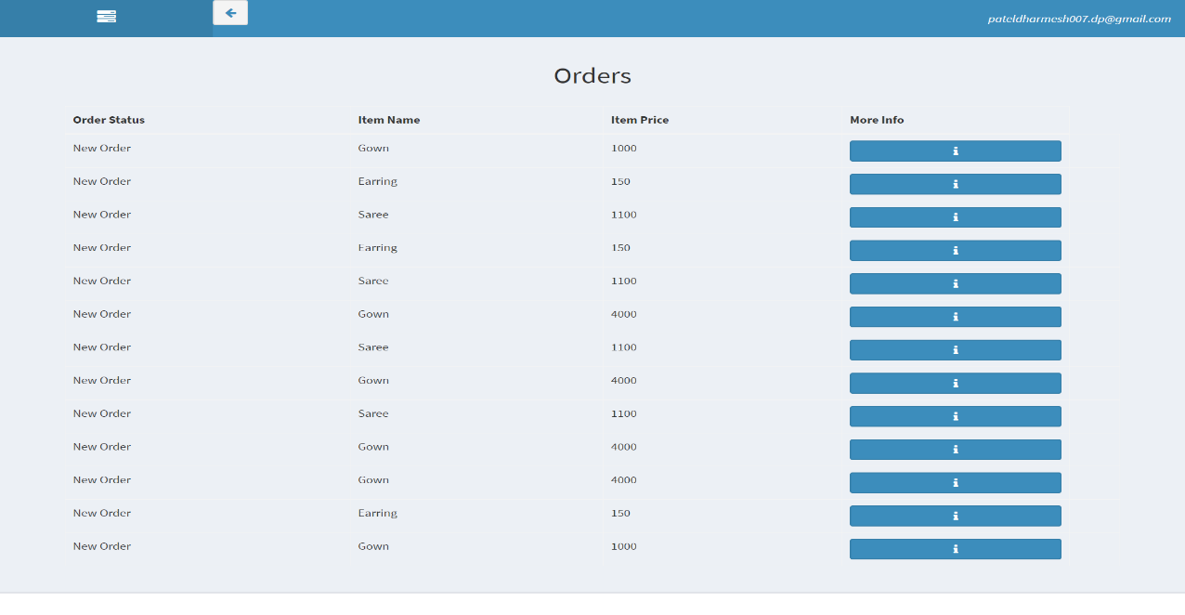

Figure 81: Current Orders

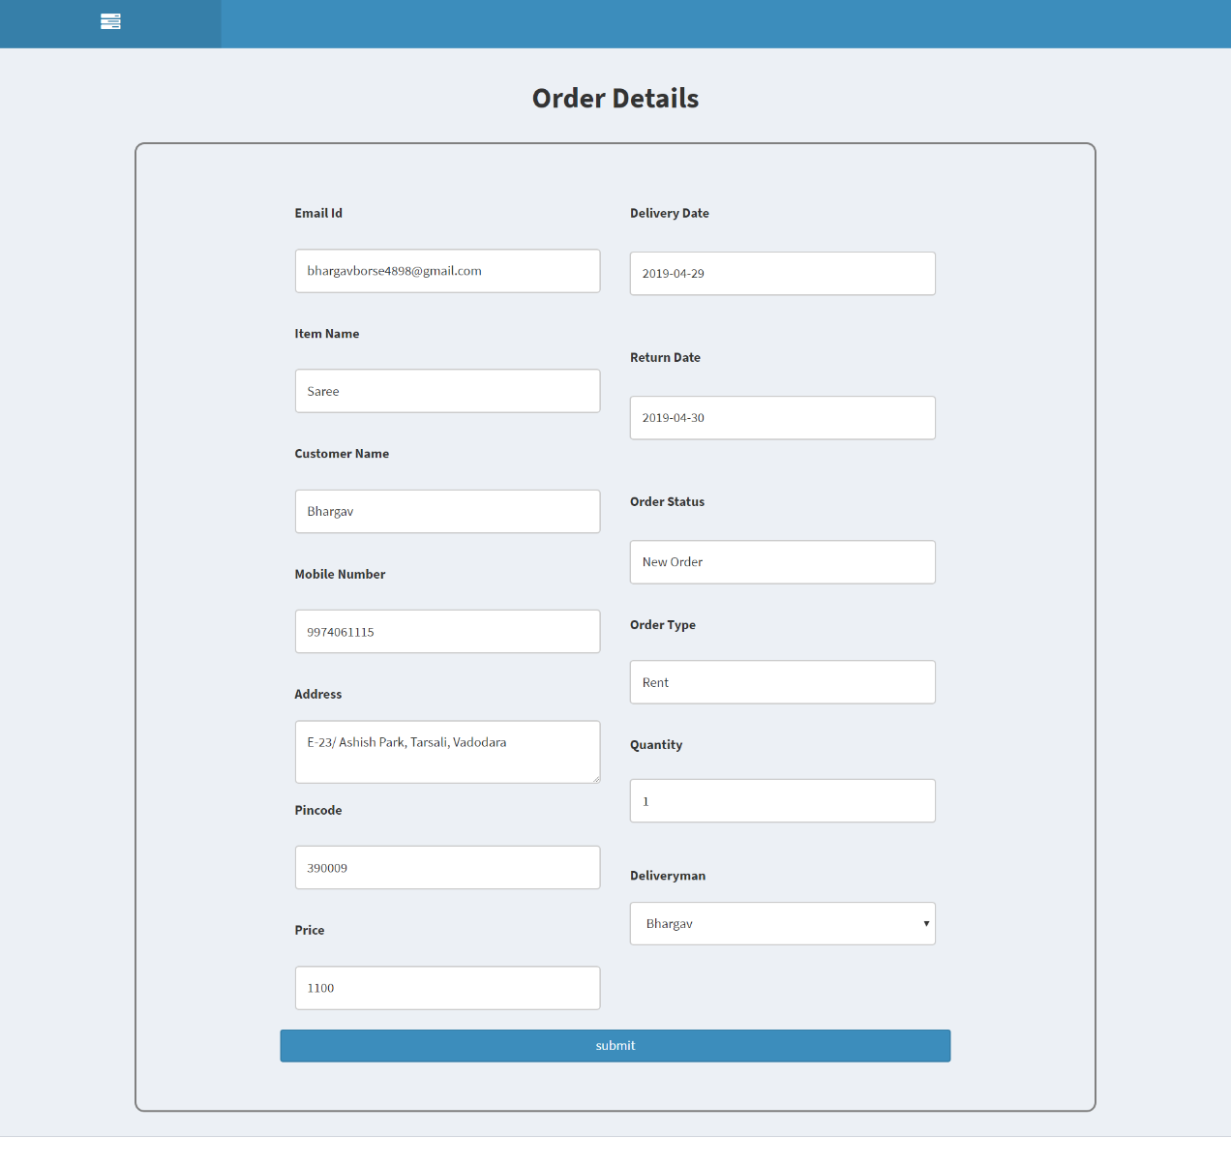

Figure 82: Order Details

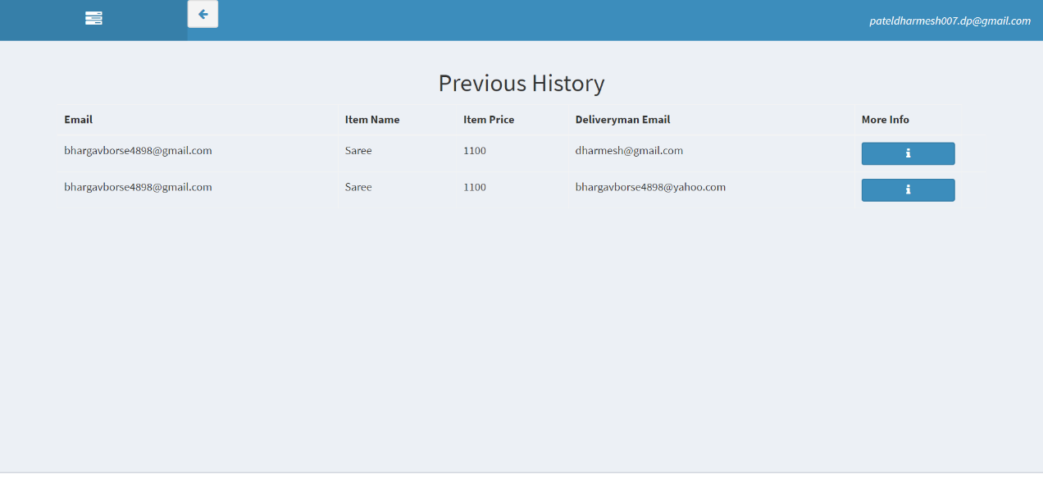

Figure 83: Previous History

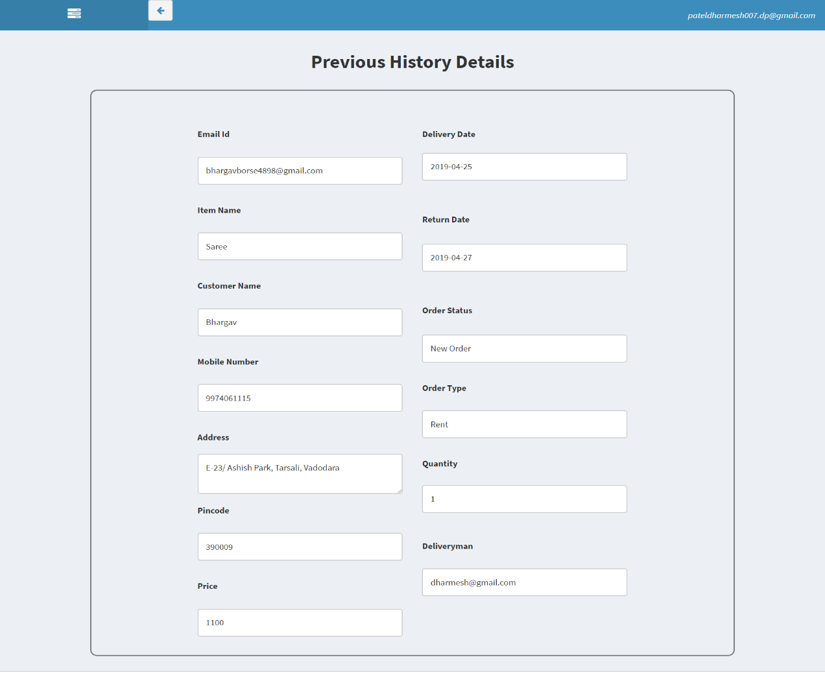

Figure 84: Previous History Order Details

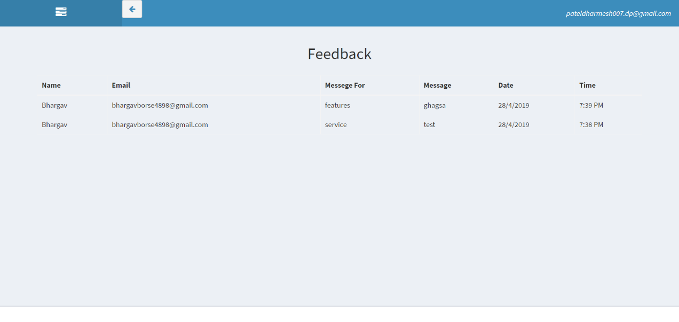

Figure 85: Feedback

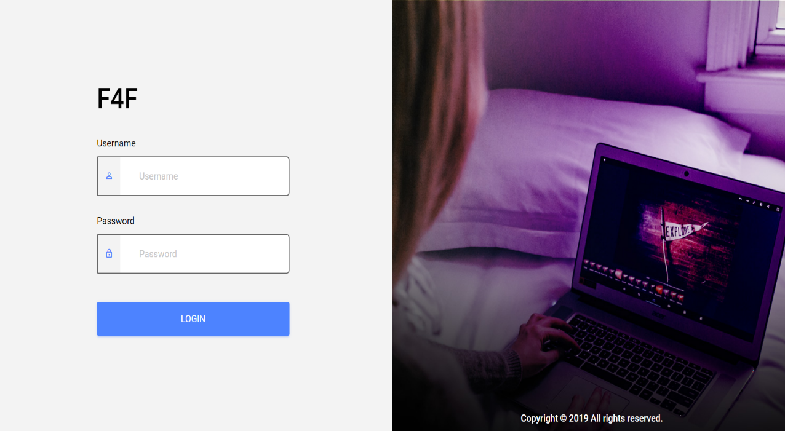

Figure 86: Deliveryman Login

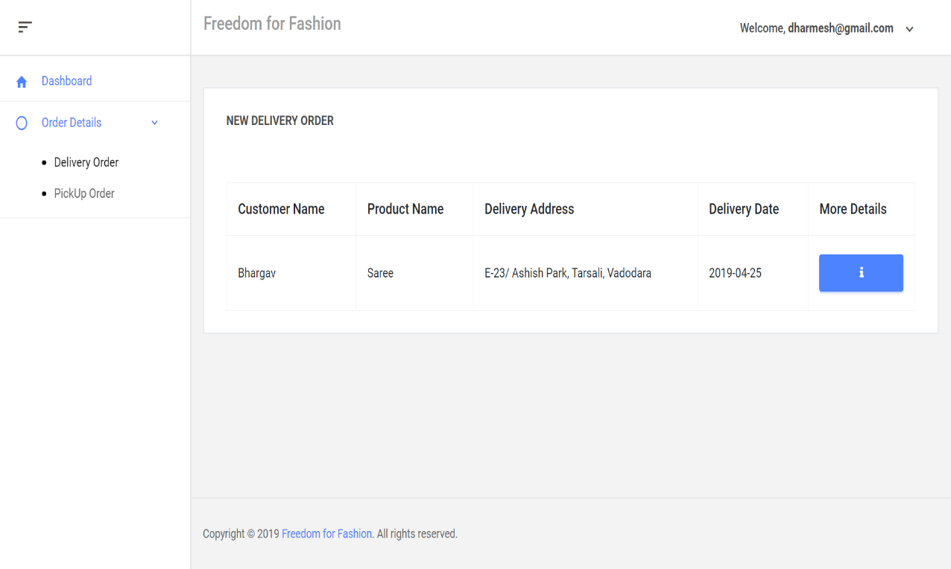

Figure 87: Delivery Order

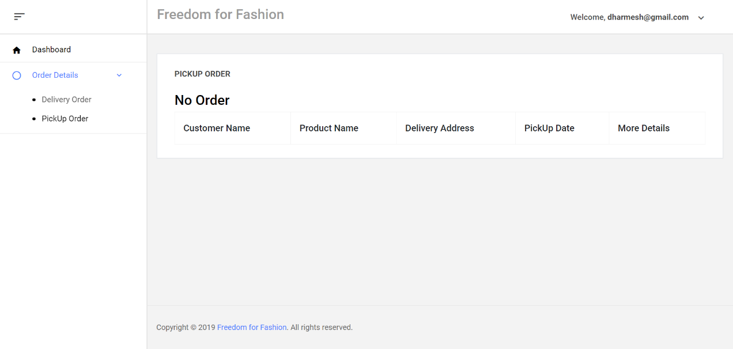

Figure 88: Pickup Order

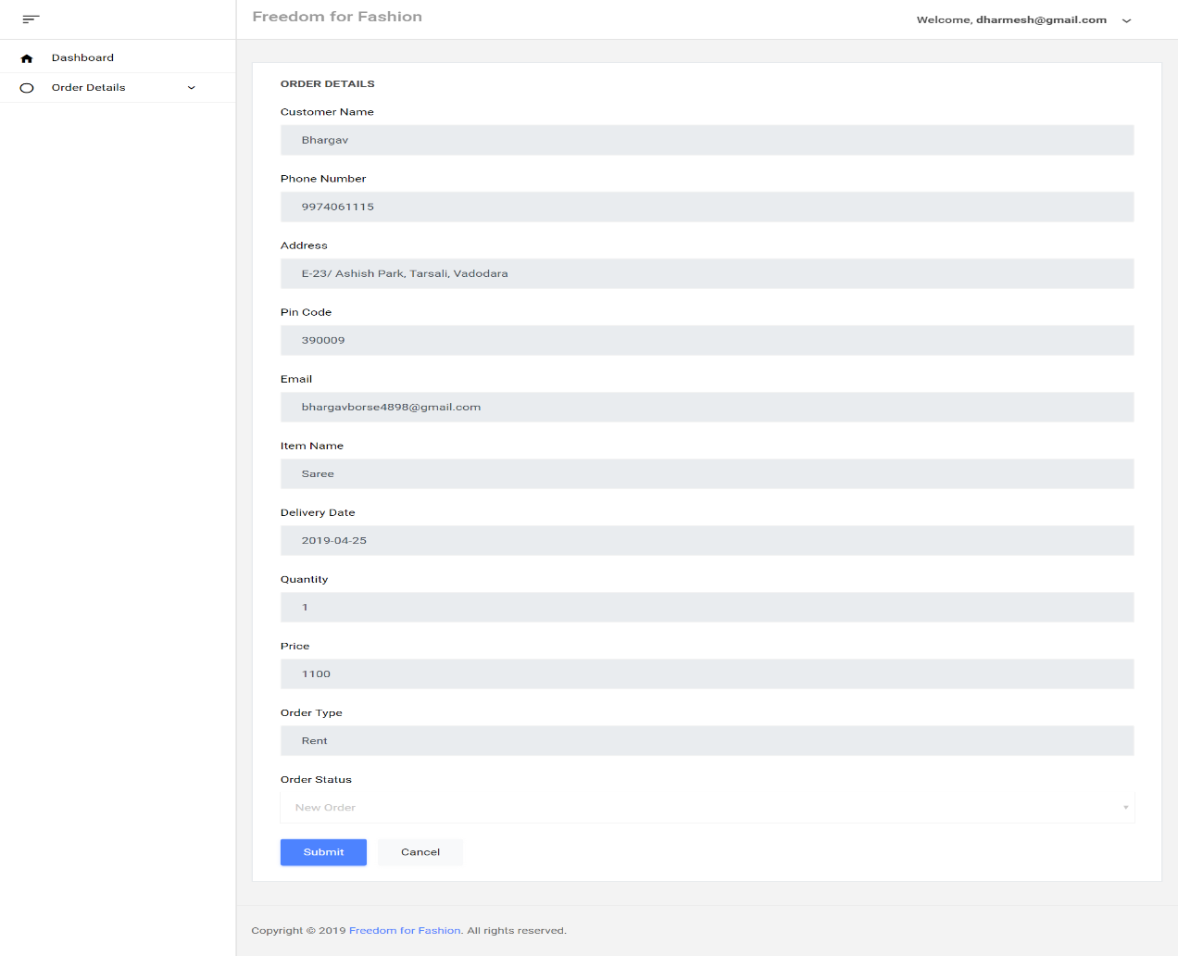

Figure 89: Delivery/Pickup Order Details

# LIMITATIONS AND FUTURE ENHANCEMENTS

Though our web-application is ready with basic requirements, there are certain limitations. Our system is only one city based. It also don’t have wish-list feature, filter by category feature. We have only cash on delivery system.

For future enhancement, we have to make the web-application more user friendly and also make it multi city/ state based application. Add to wish-list and filter feature should also be added for the users. In our current system we are showing joining date of customer on that basis in future we will give loyalty points for discount. We will add online payment system.

# CONCLUSION

This internship provided an experience of learning and skill development. It helped us to extend our sense of understanding and knowledge. It had us open to new languages and functions, made us learn its different features and made us understand the process of developing a product from scratch to end.

# REFRENCES

1. bradford. (2009, September 20). functional. Retrieved from software testing: http://softwaretestingfundamentals.com/functional-testing/
2. Elliot. (1970). SDLC. Retrieved from Tutorials Point: https://www.tutorialspoint.com/sdlc/sdlc_overview.htm
3. H.W.L. (1996, December 17). test plannig activities. Retrieved from tutorials point: https://www.tutorialspoint.com/software_testing_dictionary/test_plan.htm
4. Roy, R. (2004, 02 18). Feasibility Test. Retrieved from Tutorials Point: https://www.tutorialspoint.com/software_engineering/software_requirements.htm
5. Security Features. (2002, January 16). Retrieved from Firebase: https://firebase.google.com/docs/database/security
6. Steave, T. (2007, 5 8). Coding standars. Retrieved from Codeahay: https://codeahoy.com/2016/05/22/effective-coding-standards/
7. Strashan. (2004). Spiral. Retrieved from Tutorials Point: https://www.tutorialspoint.com/sdlc/sdlc_spiral_model.htm
8. test methods. (1970). Retrieved from tutorial point: https://www.tutorialspoint.com/software_testing/software_testing_methods.htm
9. test strategy. (1993). Retrieved from ecomupternotes: http://ecomputernotes.com/software-engineering/software-testing-strategies
10. Testing. (1996, july 15). Retrieved from Tutorials Point: https://www.tutorialspoint.com/software_testing/
11. ut. (2018, August 19). Retrieved from tutorials point: https://www.tutorialspoint.com/software_testing_dictionary/usability_testing.htm
12. W3C. (1993). gui. Retrieved from tutorials point: https://www.tutorialspoint.com/graphical-user-interface-gui